Cross-Subject Transfer Learning Based Compact Convolutional Neural Network for EEG-Based Motor Imagery Classification
Halwathurage H.O.M.B
215526U
BSc Hons in Artificial Intelligence

Department of Computational Mathematics
Faculty of Information Technology
University of Moratuwa
August 2026

Cross-Subject Transfer Learning Based Compact Convolutional Neural Network for EEG-Based Motor Imagery Classification
Halwathurage H.O.M.B
215526U
BSc Hons in Artificial Intelligence

Department of Computational Mathematics
Faculty of Information Technology
University of Moratuwa
August 2026

DECLARATION
I declare that this is my own work and this thesis/dissertation does not incorporate without acknowledgement any material previously submitted for a degree or diploma in any other University or Institute of higher learning and to the best of my knowledge and belief it does not contain any material previously published or written by another person except where the acknowledgement is made in the text.
I retain the right to use this content in whole or part in future works (such as articles or books).

Signature: ..................................................... Date: ….02/08/2026..............
The above candidate has carried out research for the undergraduate thesis/dissertation under my supervision. I confirm that the declaration made above by the student is true and correct.
Name of Supervisor: .... Dr. Thilini Piyathilake......
Signature of the Supervisor: ..................................................... Date: ........................

DEDICATION
I dedicate this thesis with heartfelt gratitude to my loving family, whose unwavering faith in me, endless encouragement, and countless sacrifices have been my greatest source of strength throughout my academic journey. Their love and support have inspired me to persevere through every challenge and celebrate every achievement.
I am also deeply grateful to my friends, mentors, and well-wishers who have offered guidance, motivation, and encouragement along the way. Their support has played an invaluable role in helping me complete this research successfully.
My sincere appreciation also goes to my school and the University of Moratuwa for providing me with the knowledge, opportunities, and learning environment that have shaped both my academic and personal growth.
Finally, I dedicate this work to everyone who has contributed to my journey, whether directly or indirectly. Your kindness, inspiration, and belief in my potential have made this accomplishment possible.

ACKNOWLEDGEMENT
I would like to express my deepest gratitude to my supervisor, Dr. Thilini Piyatilake, for her invaluable guidance, continuous support, and immense knowledge throughout this research project.
I extend my sincere thanks to Prof. Asoka Karunananda and Prof. Thushari Silva for their insightful feedback, encouragement, and academic support, which significantly contributed to the development of this work.
A special thank you goes out to my friends for their unwavering support, collaborative spirit, and the many brainstorming sessions that helped shape this research.
Finally, I am eternally grateful to my family for their unconditional love, patience, and endless encouragement. This journey would not have been possible without them.

ABSTRACT

Brain-Computer Interface technology translates mental activity into control commands, offering a vital communication channel for individuals with neuromuscular disorders. While Motor Imagery classification via Electroencephalogram signals and deep learning is highly effective, practical deployment is severely hindered by extreme inter-subject variability. This causes significant marginal distribution shifts, conventionally requiring lengthy 20-to-30-minute calibration sessions for new users. To address this calibration bottleneck, this research proposes the Euclidean Alignment Fine-Tuned (EA-FT) EEGNet framework, combining input-level standardization with weight-level adaptation.
The system takes raw, heterogeneous multi-channel EEG time-series data as inputs. The core process involves an unsupervised Euclidean Alignment module that mathematically normalizes spatial covariance across subjects, followed by processing through a pre-trained compact Convolutional Neural Network. During rapid transfer learning, early layers capturing universal neurophysiology are strictly frozen, while only the final user-specific classification layers are fine-tuned. The final outputs of the system are discrete motor intent predictions. The framework was rigorously evaluated using the BCI Competition IV 2a benchmark under a strict leakage-free protocol. The alignment module was shown to reduce inter-subject covariance mismatch by 99.0 % and to eliminate the 5.14-fold spread in spatial statistics between subjects. Using only 36 calibration trials, the framework achieved 74.1 % mean accuracy, 0.809 mean AUC and 0.471 mean Cohen's kappa across nine subjects while reducing calibration time by 75.9 % to 83.9 %, from twenty or thirty minutes to 4.82 minutes of real recording; a supplementary analysis showed the protocol can be shortened to 2.41 minutes for a cost of 0.5 percentage points. A controlled ablation attributed this performance to cross-subject transfer of the pre-trained representation, which outperformed a from-scratch baseline by a median of 16.98 percentage points for all nine subjects (p = 0.0039), rather than to the alignment stage. Euclidean Alignment did not improve mean accuracy but reduced the across-subject standard deviation from 15.7 to 12.4 percentage points and rescued the weakest transferrers by up to 13.0 points and is therefore identified as a robustness mechanism rather than an accuracy mechanism. The study concludes that a pre-trained cross-subject representation is the true prerequisite for few-shot motor-imagery decoding, and that the EA-FT EEGNet framework provides an efficient, plug-and-play solution suitable for real-time neurorehabilitation and assistive device control.
Keywords: Brain-Computer Interfaces, Motor Imagery, Transfer Learning, Euclidean Alignment, Convolutional Neural Networks

TABLE OF CONTENTS

DECLARATION iii
DEDICATION iv
ACKNOWLEDGEMENT v
ABSTRACT vi
TABLE OF CONTENTS vii
LIST OF FIGURES xi
LIST OF TABLES xiii
LIST OF ABBREVIATIONS xiv
LIST OF APPENDICES xvi
CHAPTER 1 1
INTRODUCTION 1
1.1 Introduction 1
1.2 Objectives 1
1.3 Problem in Brief 1
1.4 Background and Motivation 2
1.5 Novel Approach to EA-FT EEGNet 2
1.6 Resource Requirements 2
1.7 Structure of the Thesis 2
1.8 Summary 3
CHAPTER 2 4
LITERATURE REVIEW 4
2.1 Introduction 4
2.2 Chronological Review of Prior Work 4
2.2.1 Early development of EEG-based BCIs 4
2.2.2 Recent developments and Future trends 5
2.2.3 Issues and research challenges 6
2.3 Comparative Analysis of Existing Methods 6
2.4 Strengths and Limitations of Current Approaches 7
2.5 Summary of Issues 8
2.6 Discussion on Research Gaps 8
2.6.1 Definition of the Research Gap/Problem 9
2.7 Summary 9
CHAPTER 3 10
THEORETICAL FOUNDATIONS FOR THE EXTENSION 10
3.1 Introduction 10
3.2 Overview of Existing Theory 10
3.3 Revisiting the Research Gap 10
3.4 Rationale for the Extension 11
3.5 Theoretical Foundations/Inspiration for Extension 11
3.6 Characteristics of the Extension 12
3.7 Bridging the research gap with extension 12
3.8 Summary 12
CHAPTER 4 13
APPROACH 13
4.1 Introduction 13
4.2 Hypothesis and its inspiration 13
4.3 Inputs and Outputs of Extension 13
4.4 Process workflow for Extension 13
4.5 Technologies identified 14
4.6 Features of technological extension 14
4.7 Target Users / Use Scenarios 15
4.8 Positioning the Extension within the AI body of knowledge 15
4.9 Summary 15
CHAPTER 5 16
ANALYSIS AND DESIGN 16
5.1 Introduction 16
5.2 Rationale for the design of Extension 16
5.3 Top-Level Architecture 16
5.3.1 Preprocessing Module (Zone 1) 17
5.3.2 ML Engine (Zone 2 - Adaptation with Pre-trained EEGNet) 18
5.3.3 Extended module (Zone 3 - Fine-Tuning & Deployment) 18
5.4 Data Flow and Interaction Design 18
5.5 Extension Integration into AI Framework 19
5.6 Summary 19
CHAPTER 6 20
IMPLEMENTATION 20
6.1 Introduction 20
6.2 Overall Development Environment 20
6.3 Hardware and Software Platforms 20
6.4 Module-wise Implementation 21
6.4.1 Data Acquisition and Parsing 21
6.4.2 Artifact Removal (Zone 1) 22
6.4.3 Bandpass Filtering (Zone 1) 22
6.4.4 Euclidean Alignment (Zone 1) 23
6.4.5 EEGNet Architecture & Pre-training (Zone 2) 24
6.4.6 Deployable Euclidean Alignment (Zone 1, revised) 25
6.4.7 Zone 3 — Few-shot fine-tuning with leakage-free model selection 26
6.4.8 Implementation of the ablation arms 30
6.4.9 Persistence of the adapted models 31
6.5 Algorithms and Pseudocode 32
6.5.1 Variance-Based Artifact Rejection 32
6.5.2 Zero-Phase Bandpass Filtering 33
6.5.3 Euclidean Alignment (Spatial Whitening) 33
6.5.4 Layer-Freezing Logic for Network Adaptation 34
6.6 Workflow Diagrams / Flowcharts 35
6.7 Integration of Components 37
6.8 Testing During Development 37
6.9 Summary 38
CHAPTER 7 39
EVALUATION 39
7.1 Introduction 39
7.2 Evaluation Strategy 40
7.3 Experimental Setup 41
7.4 Datasets and Test Cases 44
7.5 Participants 47
7.6 Evaluation Metrics 48
7.7 Results and Analysis 50
7.7.1 Verification of the alignment stage 50
7.7.2 Source-model pre-training and zero-shot cross-subject transfer 51
7.7.3 Few-shot fine-tuning: performance of the complete framework 53
7.7.4 Error structure: confusion matrices 56
7.7.5 Threshold-independent performance: ROC analysis 57
7.7.6 Deployment-realistic alignment: eliminating transductive optimism 58
7.7.7 Ablation study: attributing performance to components 60
7.7.8 Isolating the effect of alignment at the transfer stage 62
7.7.9 Sensitivity to calibration set size 64
7.7.10 Statistical significance 66
7.8 Comparison with Existing Methods 68
7.9 Discussion of Findings 70
7.10 Summary 72
CHAPTER 8 74
CONCLUSION AND FURTHER WORK 74
8.1 Introduction 74
8.2 Summary of Research Contributions 74
8.3 Achievement of Objectives 76
8.4 Quantitative Performance Summary 78
8.5 Limitations of the Study 80
8.6 Challenges Encountered 81
8.7 Future Work 83
8.8 Summary 84
REFERENCES 86
APPENDIX 88

LIST OF FIGURES

Figure 1: Labels for points according to 10-20 electrode place 5
Figure 2 : Brain wave samples with dominant frequencies belong 5
Figure 3 : Emotive EPOC headset 5
Figure 4 : NeuroSky mindwave headset 5
Figure 5 : Top-Level Architecture of the Proposed System 17
Figure 6 : Raw EEG time-series traces for Left- and Right-Hand motor imagery 22
Figure 7 : Power Spectral Density (PSD) comparison showing mu and beta ERD. 22
Figure 8 : EEG signals before and after 8–30 Hz Butterworth bandpass filtering. 23
Figure 9 : Raw spatial covariance matrices for all nine subjects. 24
Figure 10 : Covariance matrices before (top) and after (bottom) Euclidean Alignment. 24
Figure 11: Deployable Euclidean Alignment — Reference Estimation and Fixed Application 26
Figure 12: Leakage-Free Few-Shot Fine-Tuning with Calibration-Based Model Selection 29
Figure 13: Zone 3 Few-Shot Fine-Tuning and Evaluation Loop 30
Figure 14 : Variance-Based Artifact Rejection 32
Figure 15 : Zero-Phase Bandpass Filtering 33
Figure 16 : Euclidean Alignment (Spatial Whitening) 34
Figure 17 : Layer-Freezing Logic for Network Adaptation 35
Figure 18 : Zone 1 Preprocessing and Euclidean Alignment Pipeline 36
Figure 19 : Leave-One-Subject-Out (LOSO) Pre-training Loop 37
Figure 20 : Model convergence during Leave-One-Subject-Out pre-training. 38
Figure 21: Per-subject accuracy, AUC and Cohen's κ for the EA-FT EEGNet framework after 36-trial calibration. The dashed horizontal line in each panel marks the across-subject mean. 54
Figure 22: Row-normalised confusion matrices for all nine subjects after 36-trial calibration. Rows denote the true class and columns the predicted class. 55
Figure 23: Receiver operating characteristic curves for all nine subjects after EA-FT calibration. The diagonal indicates chance performance. 57
Figure 24: Ablation study. Left: per-subject accuracy under each of the four conditions. Right: mean accuracy with standard-deviation error bars. The dashed line marks the 50 % chance level. 61
Figure 25: Zero-shot cross-subject transfer accuracy with and without Euclidean Alignment, evaluated on identical held-out trials with no fine-tuning. This isolates the effect of alignment on transfer 63
Figure 26: Classification accuracy as a function of calibration duration, averaged over nine subjects and five random partitions per point. 65
Figure 27: Accuracy versus calibration time for the proposed framework and published methods on BCI Competition IV 2a. The proposed method (star) occupies the lower-left region of the accuracy–burden trade-off. 69
Figure 28: Consolidated results dashboard. 70

LIST OF TABLES

Table 1 : Comparison of BCI Architectures and Deep Learning Models 7
Table 2: Experimental configuration and hyper-parameters of the EA-FT EEGNet framework 44
Table 3: Dataset composition and trial counts after each preprocessing stage 46
Table 4: Evaluation metrics, definitions and interpretation 50
Table 5: Alignment quality — Frobenius distance of the mean covariance matrix from the identity matrix, before and after Euclidean Alignment 50
Table 6: Zero-shot cross-subject transfer performance after Leave-One-Subject-Out pre-training 52
Table 7: Per-subject performance of the EA-FT EEGNet framework after 36-trial (≈ 4.8 min) calibration 54
Table 8: Transductive versus deployment-realistic (calibration-only) Euclidean Alignment 59
Table 9: Ablation study — classification accuracy (%) across four experimental conditions 60
Table 10: Zero-shot cross-subject transfer accuracy with and without Euclidean Alignment (no fine-tuning), evaluated on identical held-out trials 63
Table 11: Effect of calibration set size on classification accuracy (mean over 9 subjects × 5 repeats) 65
Table 12: Wilcoxon signed-rank tests of EA-FT EEGNet against each baseline (n = 9 subjects, two-sided) 67
Table 13: Comparison with published methods on BCI Competition IV 2a (left- versus right-hand motor imagery) 68
Table 14: Achievement of the four research objectives 77
Table 15: Quantitative performance summary of the EA-FT EEGNet framework 80
Table 16 : Plan of Actions 88

LIST OF ABBREVIATIONS

Abbreviations Description
BCI Brain computer interface
EEG Electroencephalogram
ERD Event-related desynchronization
CNN Convolutional Neural Networks
DBN Deep Belief Network
EA Euclidean Alignment
EA-FT Euclidean Alignment Fine-Tuned
ERN Error-Related Negativity
ERP Event-Related Potential
GAN Generative Adversarial Network
GPU Graphics Processing Unit
ICA Independent Component Analysis
LOSO Leave-One-Subject-Out
LSTM Long Short-Term Memory
MI Motor Imagery
MRCP Movement-Related Cortical Potential
PSD Power Spectral Density
RBM Restricted Boltzmann Machine
RPA Riemannian Procrustes Analysis
SMR Sensorimotor Rhythm
SSVEP Steady State Visually Evoked Potential
TL Transfer Learning
CSP Common Spatial Patterns
MDM Minimum Distance to Mean
ROC Receiver Operating Characteristic
SNR Signal-to-Noise Ratio
SPD Symmetric Positive-Definite

LIST OF APPENDICES

Appendix | Description | Page
Appendix - A | Plan of actions | 88

CHAPTER 1

INTRODUCTION

1.1 Introduction
Brain–Computer Interface (BCI) technology creates a direct communication pathway between the human brain and an external device, translating neural activity into control commands without relying on the body’s normal neuromuscular routes [2]. This capability is especially important for people with severe motor impairments, such as those caused by stroke, spinal cord injury, or amyotrophic lateral sclerosis (ALS), who may be unable to use conventional assistive technologies. Among available neuroimaging modalities, electroencephalography (EEG) remains the most practical option for BCI research and deployment because it is non-invasive, relatively low-cost, portable, and suitable for real-time use.
EEG signals are the macroscopic electrical activity of the brain recorded from the scalp. At the cellular level, these signals arise mainly from the synchronized postsynaptic potentials of large populations of pyramidal neurons in the cerebral cortex [1]. When many of these neuron’s fire in a coordinated manner, weak extracellular currents form; after attenuation through brain tissue, skull, and scalp, the residual potentials appear at the surface as microvolt-range fluctuations. Because the signal must pass through several layers of tissue, scalp EEG has an inherently low signal-to-noise ratio and is easily contaminated by artifacts such as eye blinks (EOG) and muscle activity (EMG).
The raw EEG waveform is commonly decomposed into clinically and functionally meaningful frequency bands: delta (0.5–4 Hz), theta (4–8 Hz), alpha (8–13 Hz), beta (13–30 Hz), and gamma (above 30 Hz) [14]. For motor-related BCIs, the most informative components lie in the sensorimotor rhythms, particularly the mu rhythm (approximately 7–13 Hz) and the beta band (approximately 13–30 Hz). These rhythms are strongly associated with motor planning and execution and form the neurophysiological basis of Motor Imagery (MI) decoding.
Several EEG-based control paradigms have been developed to turn brain activity into device commands. Steady-State Visually Evoked Potentials (SSVEP) are elicited when a user gazes at a flickering visual stimulus and produces oscillatory responses at the stimulus frequency and its harmonics. The P300 event-related potential is a positive deflection occurring about 300 ms after an attended rare (“oddball”) stimulus and is widely used in communication spellers. Hybrid BCIs combine two or more signal types to improve reliability and command diversity. In contrast, Motor Imagery is an endogenous paradigm: the user mentally rehearses a movement (for example, left hand, right hand, feet, or tongue) without physically executing it. This mental rehearsal modulates sensorimotor rhythms over the corresponding cortical areas and produces characteristic Event-Related Desynchronization (ERD) and Event-Related Synchronization (ERS) patterns in the mu and beta bands [1], [2]. Because MI does not require continuous external stimulation, it is particularly suitable for continuous device control and neurorehabilitation.
Spatially, motor imagery activity is concentrated over the sensorimotor cortex, especially regions around the central sulcus. In practice, these signals are captured non-invasively using electrodes placed on the scalp according to the International 10–20 system, which standardizes electrode locations relative to underlying cortical areas [1]. A typical acquisition chain consists of electrodes (wet or dry), conductive media, high-gain amplifiers, filtering stages, and an analog-to-digital converter that digitizes the multi-channel time series for computer processing. Modern consumer and research headsets (for example, Emotiv and NeuroSky-type systems) have improved portability, but clinical and benchmark studies still commonly rely on denser electrode montages to preserve spatial resolution over motor areas. In this research, the benchmark signals come from the BCI Competition IV 2a dataset, which records multi-channel EEG during cued motor imagery tasks from multiple subjects under controlled conditions.
Once acquired, EEG trials must be transformed into reliable motor-intent predictions. A conventional MI-BCI pipeline therefore proceeds through signal acquisition, preprocessing, feature learning or extraction, and classification. Compact convolutional neural networks such as EEGNet have proven effective for this task because they can learn discriminative temporal and spatial filters directly from multi-channel EEG [8]. However, practical deployment is hindered by extreme inter-subject variability. Differences in anatomy, skull conductivity, electrode placement, and cognitive baseline cause strong shifts in the statistical distribution of EEG across users. As a result, a classifier trained on one subject often fails on another, and new users are forced into lengthy 20–30-minute calibration sessions before the system becomes usable [5], [6].
To address this calibration bottleneck, this thesis proposes the Euclidean Alignment Fine-Tuned (EA-FT) EEGNet framework. The end-to-end story of the proposed system can be summarized as follows. First, raw multi-channel EEG is acquired while the user performs (or imagines) motor tasks. Second, the signals are cleaned and band-limited to the MI-relevant 8–30 Hz range to emphasize mu/beta activity and suppress irrelevant noise. Third, unsupervised Euclidean Alignment normalizes spatial covariance across subjects so that heterogeneous EEG distributions are mapped into a more comparable input space. Fourth, a compact EEGNet model, pre-trained on data from other subjects, extracts universal sensorimotor features; early layers that capture common neurophysiological patterns are kept frozen, while only the later user-specific layers are fine-tuned with a small number of calibration trials. Finally, the adapted network outputs discrete motor-intent class predictions (for example, left-hand versus right-hand imagery), which can be mapped to assistive-device commands.
In this way, the research follows a complete flow from the biological origin of EEG, through motor-imagery generation and scalp-level capture, to alignment-aware transfer learning and few-shot prediction. The intended outcome is a more practical MI-BCI pipeline that preserves competitive decoding accuracy while substantially reducing the calibration burden for new users.

1.2 Objectives
- To conduct a comprehensive review of existing EEG-based motor imagery classification techniques and deep learning architectures.
- To investigate the underlying theoretical frameworks and analyze the challenges associated with inter-subject variability and calibration in EEG-based BCIs.
- To propose and implement the "EA-FT EEGNet" framework, a compact Convolutional Neural Network system that incorporates Euclidean Alignment for input standardization and conservative fine-tuning for cross-subject transfer learning.
- To experimentally evaluate the proposed framework using benchmark EEG datasets (BCI Competition IV 2a) to demonstrate a reduction in calibration time while maintaining robust classification accuracy.

1.3 Problem in Brief
Despite the efficiency of compact architecture, EEG-based BCIs suffer from extreme Inter-Subject Variability. Factors such as differences in brain anatomy, skull thickness, electrode placement, and baseline cognitive states cause significant shifts in the marginal distribution of brain signals across users [5] [6]. Consequently, a model trained on one subject performs poorly on another, forcing new users to undergo a tedious 20–30-minute calibration process to re-train the network [6]. The lack of standardized input space alignment before EEG data reaches the neural network prevents efficient transfer learning. Without aligning heterogeneous subject distributions first, fine-tuning efforts struggle to "unlearn" source subject characteristics, often leading to "Catastrophic Forgetting" where previously learned universal rhythms are overwritten by noisy, user-specific execution patterns.

1.4 Background and Motivation
Brain signals are inherently non-stationary and exhibit unique topographical distributions for every individual. This non-stationarity leads to a Marginal Distribution Shift, where the raw input data space differs so drastically between subjects that standard Transfer Learning (TL) fails to generalize [3, 7]. Current systems address this by requiring new users to perform repetitive MI tasks for approximately 30 minutes to collect sufficient labeled data for a subject-specific model [3], a process that is exhausting for patients with motor disabilities. The "calibration bottleneck" is a primary barrier to the practical deployment of BCI systems in real-world environments [8]. If calibration time can be reduced to less than 5 minutes, BCIs could transition into "plug-and-play" assistive technologies for daily stroke rehabilitation or robotic prosthetic control.

1.5 Novel Approach to EA-FT EEGNet
This work proposes the EA-FT EEGNet framework, which combines Euclidean Alignment for input-level signal normalization with conservative layer-wise fine-tuning of a pre-trained EEGNet. By adapting only user-specific layers, the framework aims to significantly reduce calibration data while preserving high classification performance. The system operates on the hypothesis that alignment is a prerequisite for efficient transfer learning. Instead of feeding raw data, an unsupervised Euclidean Alignment process transforms every trial, so the average covariance matrix becomes the identity matrix. The pre-processed data is fed into a pre-trained EEGNet. The first block (Temporal and Depth wise convolutions) is Frozen to preserve "universal" brain rhythms like mu and beta common to all humans. The second block (Separable Convolution and SoftMax) is Unfrozen to adapt the mixing logic to user-specific execution patterns using a low learning rate.

1.6 Resource Requirements
- Hardware: High-performance workstation with NVIDIA GPU (RTX 4050) for source model pre-training.
- Software: Python, PyTorch/TensorFlow, and the Brain decode library for EEG deep learning.
- Tools: EEGLAB (MATLAB) with the ADJUST plugin for initial artifact characterization.
- Data: BCI Competition IV 2a (Graz dataset) for benchmarking.

1.7 Structure of the Thesis
This thesis follows a milestone approach spanning from literature review to final evaluation. Chapter 1 introduces the research, while Chapter 2 provides a chronological review of prior work. Chapter 3 discusses theoretical foundations, followed by the proposed approach in Chapter 4. Chapter 5 details analysis and design, Chapter 6 covers implementation, Chapter 7 presents the evaluation, and Chapter 8 concludes with further work.

1.8 Summary
This chapter introduced the EA-FT EEGNet framework to solve the calibration bottleneck in MI-BCI systems. By combining unsupervised Euclidean Alignment for input-level standardization and conservative fine-tuning for weight-level adaptation, the system targets a reduction in calibration time of more than 75 %, from 20–30 minutes to under 5 minutes while maintaining robust classification accuracy. The expected outcome is a robust, "plug-and-play" algorithmic model that significantly enhances the usability of BCI technology for neurorehabilitation and assistive device control.

CHAPTER 2

LITERATURE REVIEW

2.1 Introduction
Electroencephalography (EEG) is the most widespread, cost-effective, and safe non-invasive neuroimaging technique for recording the brain's electrical activity [1], [19]. Fundamentally, an EEG-based Brain-Computer Interface (BCI) functions as a system that captures, analyzes, and translates cerebral activity into output commands that control computers or external devices, completely bypassing the body's normal neuromuscular pathways [4], [19]. This capability is vital for individuals with severe motor deficits who cannot use conventional assistive technologies [18]. This chapter traces the evolution of EEG-based BCIs, critically examining historical developments, the integration of Artificial Intelligence (AI), and the current challenges that necessitate novel approaches like domain alignment.

2.2 Chronological Review of Prior Work

2.2.1 Early development of EEG-based BCIs
The foundational work for EEG can be traced back to Hans Berger in the 1920s, who successfully recorded weak electric currents from the human scalp and identified that brain activity patterns change according to functional status [1]. The concept of using brain signals to control external devices emerged in 1971, but the formalization of BCI technology truly began with pioneering studies in 1991. Research demonstrated that subjects could learn to control a computer cursor by voluntarily modulating their sensorimotor rhythms (SMRs), establishing a foundational proof-of-concept for operant conditioning in device control [6]. This early era relied heavily on traditional wet electrodes utilizing silver/silver-chloride (Ag/AgCl) sensors and conductive gels to reduce skin–electrode impedance below 5kΩ [1], [3]. While offering superior signal fidelity, these setups required time-consuming preparation and expert assistance, restricting BCIs primarily to clinical and laboratory environments [6], [13].
Figure 1 represents the International 10–20 electrode placement system used for standardized scalp EEG recording. The diagram shows the top view of the head with electrode positions labeled relative to anatomical landmarks (nasion and inion), including frontal (Fp1, Fp2, Fz, F3, F4, F7, F8), central (C3, Cz, C4), temporal (T3, T4, T5, T6), parietal (P3, Pz, P4), and occipital (O1, Oz, O2) sites. Distances between neighboring electrodes are defined as 10% or 20% of the nasion–inion or left–right reference measurements, which ensures consistent coverage of cortical regions. For motor imagery BCIs, electrodes over the sensorimotor cortex—especially C3, Cz, and C4—are particularly important because they capture mu and beta rhythm changes associated with imagined left- and right-hand movements.
Figure 2 represents sample EEG waveforms for the major brain-wave frequency bands: beta, alpha (alfa), theta, and delta. From top to bottom, the traces illustrate a progressive decrease in oscillation frequency. Beta waves are the fastest and are linked to active thinking and focused attention; alpha waves are slower and associated with a relaxed, awake state (the motor-related mu rhythm falls within this range); theta waves appear during drowsiness or deep meditation; and delta waves are the slowest and dominate deep sleep. In the present study, motor imagery decoding primarily relies on the mu/alpha and beta bands (approximately 8–30 Hz), because these rhythms show Event-Related Desynchronization (ERD) and Event-Related Synchronization (ERS) during imagined movement.

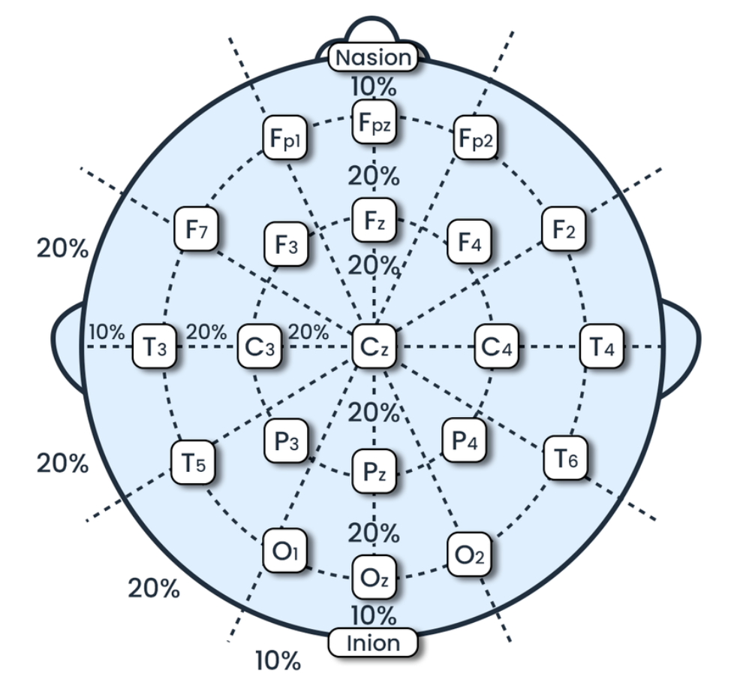  Figure 1: Labels for points according to 10-20 electrode place | 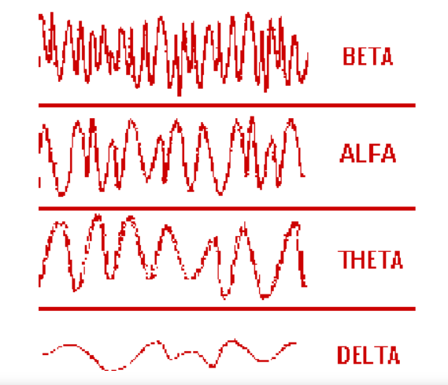  Figure 2 : Brain wave samples with dominant frequencies belong

2.2.2 Recent developments and Future trends
The most significant recent development in BCI technology is the transition from manual signal processing to Artificial Intelligence (AI) and Deep Learning (DL) [4], [15]. Modern DL architecture enables end-to-end learning, where models accept raw or minimally pre-processed EEG data and automatically discover hierarchical features, eliminating the bottleneck of manual feature engineering [10], [13]. Convolutional Neural Networks (CNNs), particularly the compact EEGNet, have revolutionized the field by successfully classifying multi-paradigm signals (MI, P300, SSVEP) while minimizing trainable parameters [17].
Simultaneously, hardware has evolved toward portable, wireless dry-electrode headsets (e.g., Emotiv, NeuroSky) that support rapid, self-administered deployment [10], [15]. Looking toward the future, the field is advancing toward Hybrid BCIs that combine multiple modalities (e.g., EEG with fNIRS or EOG) to maximize reliability [13], [16], as well as Shared Autonomy models where AI handles low-level execution (like a robotic grasp) while the human provides high-level intent [4].
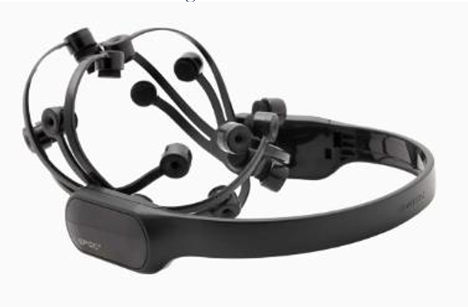  Figure 3 : Emotive EPOC headset | 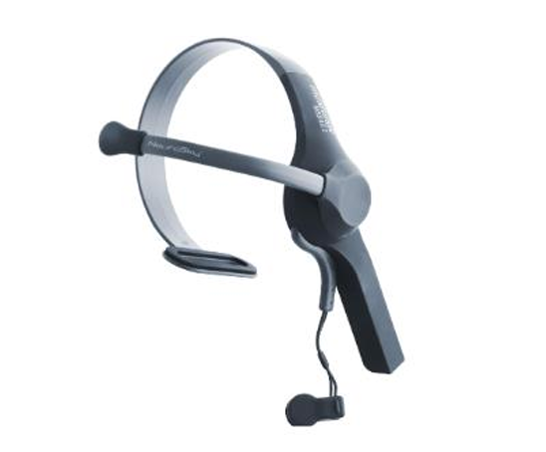  Figure 4 : NeuroSky mindwave headset

Figure 3 shows the Emotiv EPOC headset, a wireless multi-channel EEG device with multiple scalp sensors for recording brain activity from several regions at once. Figure 4 shows the NeuroSky MindWave headset, a simpler single-channel EEG device with a forehead sensor and an ear-clip reference electrode for portable signal capture.

2.2.3 Issues and research challenges
Despite these advancements, practical BCI deployment is severely hindered by the inherent nature of EEG signals. The signal must pass through brain tissues, the skull, and the scalp, resulting in significant attenuation and a drastically low Signal-to-Noise Ratio (SNR) [3], [13]. Furthermore, BCI research is constrained by data scarcity, as collecting high-quality, labeled EEG data is a labor-intensive process sensitive to environmental noise [10], [13]. However, the most persistent obstacle remains electrophysiological variability. Extreme non-stationarity both inter-subject (differences between users) and intra-subject (changes within a single user due to fatigue or electrode shift) causes models to fail when transferring between users, creating a massive barrier to "plug-and-play" functionality [9], [15].

2.3 Comparative Analysis of Existing Methods
Historically, BCI pipelines relied on traditional feature extraction algorithms combined with linear classifiers. While computationally light, these methods struggle to decode latent patterns in highly noisy environments. In contrast, Deep Learning approaches like CNNs provide robust spatial-temporal feature extraction, while Recurrent Neural Networks (RNNs) excel at tracking temporal dynamics for cognitive monitoring [8], [13].
Regarding the handling of inter-subject variability, Transfer Learning (TL) and Domain Adaptation (DA) have emerged as primary strategies [9], [15]. Deep Transfer Learning relies on pre-training a network on a massive source domain and fine-tuning the final layers for a new user, which has successfully reduced calibration times from 30 minutes to under 2 minutes [4], [9]. Alternatively, Manifold Learning utilizing Riemannian Geometry bypasses flat vector spaces entirely, mapping the covariance matrices of EEG signals onto a symmetric positive-definite (SPD) manifold [4], [13]. Classifiers operating on this manifold, such as Minimum Distance to Riemannian Mean (MDRM), show exceptional resistance to signal drift compared to traditional Euclidean methods [4], [14].
Table 1 : Comparison of BCI Architectures and Deep Learning Models
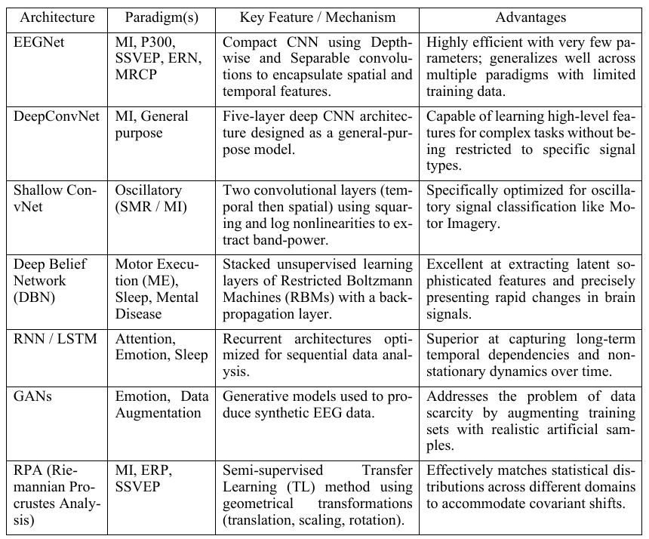

2.4 Strengths and Limitations of Current Approaches
Current deep learning approaches boast significant strengths. For instance, EEGNet's architecture utilizes depthwise and separable convolutions to remain highly parameter-efficient, making it ideal for real-time processing and minimizing the risk of overfitting on small datasets [17]. Transfer learning techniques are highly effective at leveraging existing datasets to bypass long initial training phases [10].
However, these approaches have notable limitations. Standard transfer learning can suffer from "catastrophic forgetting" if the marginal distribution shift between the source and target subjects is too extreme [3], [7]. DA techniques project features into a common subspace, but without strict input-level alignment, deep neural networks still struggle to unlearn the ingrained patterns of the source data [9]. Additionally, while dry and wireless electrodes drastically improve usability, their susceptibility to motion artifacts and higher impedance introduces a level of noise that current lightweight algorithms still struggle to filter in real-time [2], [6].

2.5 Summary of Issues
A critical synthesis of the current literature reveals that the widespread clinical adoption of Motor Imagery Brain-Computer Interfaces (MI-BCIs) is primarily obstructed by three interconnected, cascading challenges. The most immediate practical barrier is the Calibration Bottleneck. Current systems mandate that new users undergo lengthy calibration sessions, typically lasting 20 to 30 minutes, during which they must perform highly repetitive mental rehearsal tasks. For the primary target demographic patients suffering from severe neuromuscular disorders or motor impairments this extended setup induces significant cognitive and physical fatigue before the device can even be operated. This exhaustive prerequisite fundamentally prevents BCIs from functioning as practical, daily-use, "plug-and-play" assistive technologies.[3],[12] This calibration requirement is symptomatic of a deeper electrophysiological problem known as Marginal Distribution Shifts. Every human brain possesses unique anatomical characteristics, such as variations in skull thickness, cortical folding, and electrode placement impedance, combined with varying baseline cognitive states. Because of these distinct physical and mental topographies, the spatial and temporal distributions of raw EEG signals vary drastically across different individuals. Standard deep learning networks struggle to generalize across these shifts, as the mathematical distribution of the source data the model was trained on looks entirely different from the raw data space of a new target user [3],[7]. Finally, this severe domain shift leads to Inefficient Adaptation when utilizing standard transfer learning techniques. When researchers attempt to fine-tune a pre-trained network directly on a new user's highly shifted raw data, the adaptation process is notoriously data-hungry and inefficient. The neural network cannot easily reconcile the new user's unique statistical manifold with the pre-existing weights it learned from the source domain [5]. Consequently, the model is forced to drastically overwrite its internal representations, often leading to "catastrophic forgetting." During this forced retraining, the network inadvertently unlearns universal, generalized brain rhythms (such as mu and beta bands) it initially captured, necessitating even larger amounts of calibration data to regain accuracy.

2.6 Discussion on Research Gaps
While extensive research has focused on complex network architectures (like heavy CNNs or RNNs) and sophisticated downstream domain adaptation, there is a distinct lack of focus on standardized input-space alignment prior to deep learning feature extraction [7], [8]. Methods like Riemannian Alignment address this but are computationally heavy and difficult to implement in real-time, low-latency BCI systems [3], [4], [7]. There is a gap in the literature regarding the synergistic combination of lightweight unsupervised input alignment with conservative weight-level network adaptation.

2.6.1 Definition of the Research Gap/Problem
The specific research gap is the lack of an efficient, unified framework that can standardize heterogeneous EEG input distributions across subjects before processing, thereby allowing a compact network to adapt to a new user rapidly without catastrophically forgetting universal brain rhythms [4], [7]. Without aligning the raw data space first, fine-tuning efforts remain data-hungry and inefficient.

2.7 Summary
This chapter explored the theoretical and historical landscape of EEG-based BCIs, highlighting the paradigm shift brought by deep learning and compact CNNs like EEGNet [17]. While AI has vastly improved decoding accuracy, the literature confirms that inter-subject variability and the resulting calibration bottleneck remain the most critical barriers to practical use [8], [9]. Analyzing existing transfer learning and domain adaptation methods reveals a distinct research gap: the need for an efficient, input-level standardization process to facilitate rapid, few-shot calibration [4]. Bridging this gap is the primary focus of the proposed methodology in the following chapters.

CHAPTER 3

THEORETICAL FOUNDATIONS FOR THE EXTENSION

3.1 Introduction
This chapter establishes the theoretical groundwork required to address the high inter-subject variability inherent in Electroencephalogram (EEG) signals. It explores the foundational concepts of domain adaptation and transfer learning within the context of Brain-Computer Interfaces (BCIs). By critically analyzing the limitations of existing theories, this chapter provides a clear rationale for the proposed Euclidean Alignment Fine-Tuned EEGNet (EA-FT EEGNet) framework, detailing the mathematical and structural inspirations that drive this technological extension.

3.2 Overview of Existing Theory
The current theoretical paradigm for non-invasive BCI decoding relies heavily on detecting repeatable neurophysiological signatures and leveraging machine learning for pattern recognition.
- Sensorimotor Rhythms (SMR) and Motor Imagery (MI): Motor Imagery theory relies on the voluntary modulation of sensorimotor rhythms. The mental rehearsal of a limb movement generates distinct neural patterns, characterized by Event-Related Desynchronization (ERD) within the mu (8–13 Hz) and beta (13–30 Hz) frequency bands.
- Compact Convolutional Neural Networks (CNNs): Modern BCI decoding has shifted toward optimized architectures like EEGNet. EEGNet utilizes depthwise convolutions to extract frequency-specific spatial filters and separable convolutions to decouple the relationships within and across feature maps. This reduces the trainable parameter count to approximately 2,000, making it vastly more efficient and less prone to overfitting than larger models like DeepConvNet, which possess over 170,000 parameters.
- Transfer Learning (TL) and Domain Adaptation (DA): Standard TL theory involves leveraging data from a source domain (existing subjects) to initialize a model for a target domain (a new user). Domain adaptation aims to learn a target prediction function by minimizing the differences in marginal or conditional probability distributions between these domains.

3.3 Revisiting the Research Gap
Despite the theoretical promise of standard Transfer Learning, it frequently fails in practical BCI applications due to the extreme non-stationarity of brain signals [3]. The core issue lies in the "Marginal Distribution Shift." The raw input data space differs so drastically across subjects due to varying skull thickness, electrode impedance, and brain topography that the source domain and target domain do not share a common statistical manifold [5]. Consequently, fine-tuning a network without first correcting this massive input-level discrepancy forces the deep learning model to drastically overwrite its weights. This leads to "Catastrophic Forgetting," where the network unlearns the universal neurophysiological rhythms (like mu and beta bands) it initially captured, resulting in poor generalization and an inability to bypass the 20–30-minute calibration bottleneck.

3.4 Rationale for the Extension
To bridge this gap, intervention is required before the EEG data enters the neural network's feature extraction layers. The rationale for the proposed extension is that deep neural networks are highly sensitive to the scale and variance of their inputs. If heterogeneous subject distributions can be mathematically forced into a standardized space, the subsequent neural network will only need to learn the subtle, task-specific variations of the new user rather than entirely new spatial mappings. This necessitates an unsupervised domain adaptation technique that is computationally lightweight, combined with a highly compact CNN to prevent overfitting on the small datasets acquired during a rapid (< 3 minute) calibration phase [8].

3.5 Theoretical Foundations/Inspiration for Extension
The extension integrates two primary mathematical and architectural concepts to achieve domain invariance:
- Euclidean Alignment (EA): EA is an unsupervised data whitening technique drawn from manifold learning. Instead of treating covariance matrices as points on a complex Riemannian manifold which is computationally heavy EA transforms the trials into Euclidean space so that their average covariance matrix equates to the identity matrix. Mathematically, for a set of trials $Xi$, the reference covariance matrix $\overline{R}$ is calculated as:

The alignment is then applied by projecting the raw signals into a standardized space:


- Layer-wise Freezing in Compact CNNs: Drawing from the EEGNet architecture, the temporal and spatial convolution layers act as universal bandpass and spatial filters [8]. The theoretical inspiration is that these early layers learn universal human brain rhythms. By explicitly freezing them during transfer learning, we preserve core feature extraction while only fine-tuning the downstream separable convolution layers that handle user-specific mixing logic.

3.6 Characteristics of the Extension
The proposed EA-FT EEGNet extension is characterized by its dual-stage adaptation capability. It is highly parameter-efficient, utilizing the compact nature of EEGNet (~2,000 parameters) to ensure it can be trained on minimal calibration data without succumbing to overfitting [8]. The extension is also paradigm-agnostic, unsupervised at the alignment stage, and computationally inexpensive, making it highly suitable for real-time, low-latency deployment in clinical settings.
- Computational Efficiency: Unlike Riemannian Alignment (RA) which requires complex mapping to and from symmetric positive-definite manifolds, EA is computationally lightweight because it operates entirely within Euclidean space.
- Parameter Stability: By freezing Block 1, the framework maintains the integrity of general neurophysiological features, preventing overfitting on small calibration datasets.
- Few-Shot Efficiency: The synergistic combination of EA and conservative fine-tuning targets a massive reduction in calibration data requirements, driving the setup time down from a traditional 20-30 minutes to under 3 minutes.

3.7 Bridging the research gap with extension
The extension bridges the research gap by standardizing the input space before attempting weight-level adaptation. By applying Euclidean Alignment, the marginal distribution shift is virtually eliminated, pushing the target user's data into the same statistical space as the source dataset. Once aligned, the frozen-layer fine-tuning strategy allows the network to adapt smoothly and conservatively. This completely bypasses the catastrophic forgetting phenomenon, ensuring that the model retains its fundamental understanding of motor imagery while accommodating the new user, drastically cutting the required calibration time.

3.8 Summary
This chapter outlined the theoretical limitations of standard deep transfer learning in highly non-stationary EEG environments. It established the mathematical and structural rationale for combining Euclidean Alignment with conservative fine-tuning on a compact CNN. By standardizing the input data space and preserving universal feature extractors, this theoretical foundation supports the rapid, few-shot calibration framework proposed to overcome the inter-subject variability bottleneck.

CHAPTER 4

APPROACH

4.1 Introduction
This chapter presents the conceptual blueprint for the EA-FT EEGNet framework. It outlines the overarching hypothesis, details the specific inputs and outputs of the proposed system, and describes the step-by-step process workflow designed to significantly reduce BCI calibration time. Furthermore, it identifies the targeted users and positions this technological extension within the broader landscape of Artificial Intelligence.

4.2 Hypothesis and its inspiration
The core hypothesis of this research is that input-level alignment is a strict prerequisite for efficient, rapid transfer learning in highly non-stationary physiological signals. It is hypothesized that applying unsupervised Euclidean Alignment to normalize signal covariance, followed by freezing early universal-feature layers in a compact CNN (EEGNet), will reduce the required user calibration time by over 80% while maintaining robust classification accuracy. This hypothesis is inspired by the observation that deep learning models fail not because they lack capacity, but because unaligned raw EEG data spaces present irreconcilable statistical distributions during few-shot fine-tuning. This hypothesis is tested directly and in isolation in section 7.7.8, where the alignment stage is evaluated at the transfer stage with fine-tuning removed; the outcome of that test, and the revision to the hypothesis it necessitates, are discussed in section 7.9.

4.3 Inputs and Outputs of Extension
- Inputs: The framework accepts raw, multi-channel EEG time-series data represented as an E$×$T matrix, where E represents the number of spatial electrode channels and T represents the number of discrete time samples recorded during a specific motor imagery task (e.g., 2 to 4 seconds of mental rehearsal).
- The final output of the extension is a discrete, multi-class prediction indicating the user's specific motor intent. For benchmark evaluation, this is typically a classification label mapping to distinct commands (e.g., Class 0: Left Hand, Class 1: Right Hand, Class 2: Both Feet, Class 3: Tongue).

4.4 Process workflow for Extension
The conceptual workflow of the EA-FT EEGNet extension is divided into three primary zones:
- Zone 1 - Global Pre-processing & Alignment: Raw continuous EEG signals are first cleaned using automated artifact removal techniques (such as ICA-ADJUST) to eliminate ocular and muscular noise. The clean signal is bandpass filtered (typically 8–30 Hz to isolate mu and beta rhythms). Crucially, the data then passes through the Euclidean Alignment module, which acts as an unsupervised spatial whitener, forcing the average covariance matrix of the trials to the identity matrix.

- Zone 2 - Core Architecture Setup: A base EEGNet model, pre-trained on a massive multi-subject source dataset, is loaded. To prepare for the new target user, the network's architecture is bifurcated. Block 1 (Temporal and Depthwise convolutions) is mathematically frozen to lock in universal spatial filters. Block 2 (Separable convolutions and the Softmax classification layer) remains unfrozen.

- Zone 3 - Few-Shot Fine-Tuning & Deployment: During the rapid calibration phase, a minimal amount of target data (e.g., 2-3 minutes of recorded MI tasks) is fed into the network. A conservative fine-tuning loop updates only the weights in Block 2 utilizing a low learning rate. After this brief update, the model enters deployment mode, providing real-time, high-accuracy control signals for the user.

4.5 Technologies identified
To realize this approach, several specific technologies have been identified:
- Deep Learning Framework: PyTorch or TensorFlow will be utilized to construct, pre-train, and manipulate the layer-wise gradients of the EEGNet architecture.
- Signal Processing & BCI Libraries: Braindecode and MNE-Python are required for efficient EEG data loading, epoching, and mathematical transformations (including Euclidean Alignment).
- Pre-processing Tools: EEGLAB (a MATLAB extension) with the ADJUST plugin will be used for the initial offline characterization and removal of complex independent component artifacts.

4.6 Features of technological extension
The proposed extension features several distinct technological advancements:
- Unsupervised Adaptability: The alignment process does not require labeled data from the target user, operating purely on the statistical properties of the raw signal.
- Parameter Efficiency: By utilizing EEGNet and freezing its largest initial blocks, the trainable parameter space during fine-tuning is reduced to a few hundred weights, mitigating overfitting.
- Plug-and-Play Readiness: The architecture explicitly trades lengthy user-training for algorithmic intelligence, generating a system designed for rapid deployment.

4.7 Target Users / Use Scenarios
The primary target users for this extension are individuals suffering from severe motor impairments, including those with Amyotrophic Lateral Sclerosis (ALS), spinal cord injuries, or locked-in syndrome [2][6]. The primary use scenario is daily neurorehabilitation. Instead of spending 30 minutes calibrating a system before a therapy session which causes mental fatigue before the actual session begins a stroke patient can wear an EEG headset, perform a brief 2-minute baseline test, and immediately begin using the BCI to control a robotic exoskeleton or communication interface.

4.8 Positioning the Extension within the AI body of knowledge
Within the broader Artificial Intelligence body of knowledge, this research bridges three distinct domains: Time-Series Deep Learning, Domain Adaptation, and Transfer Learning [5][6]. While traditional AI computer vision utilizes transfer learning effortlessly (e.g., fine-tuning ResNet), physiological signals like EEG break standard assumptions of data stationarity. This extension positions itself as a specialized solution within "Deep Domain Adaptation for Physiological Signals," proving that algorithmic mathematical alignment must precede deep feature extraction for non-stationary biological data.

4.9 Summary
This chapter detailed the logical approach of the EA-FT EEGNet framework. Grounded in the hypothesis that spatial alignment dictates transfer learning success, the framework processes raw EEG inputs through an unsupervised Euclidean transformation before applying few-shot fine-tuning to a partially frozen compact CNN. Aimed at drastically improving the quality of life for motor-impaired individuals, this approach represents a significant step forward in making AI-driven BCI systems practical, efficient, and user-friendly for real-world deployment.

CHAPTER 5

ANALYSIS AND DESIGN

5.1 Introduction
This chapter translates the conceptual approach established in Chapter 4 into a concrete system architecture. It details the structural and logical design of the Euclidean Alignment Fine-Tuned EEGNet (EA-FT EEGNet) framework. By breaking down the system into modular components preprocessing, the machine learning engine, and the deployment module, this chapter defines the data flow and architectural rationale that enables rapid, few-shot calibration for Motor Imagery (MI) classification.

5.2 Rationale for the design of Extension
The primary rationale behind the EA-FT EEGNet design is to enforce a strict separation between domain generalization (handling universal brain patterns) and domain adaptation (handling user-specific nuances). A monolithic, fully trainable deep learning model is highly susceptible to overfitting when exposed to the very small datasets expected during a 2–3-minute calibration window. By designing modular architecture, the system isolates the input standardization process (Euclidean Alignment) from the neural network. This ensures that the deep learning model receives statistically uniform data. Furthermore, by bifurcating the EEGNet architecture into "Frozen" and "Unfrozen" blocks, the design mathematically protects the universal spatial and temporal filters from catastrophic forgetting, focusing all learning capacity on the final mixing layers.

5.3 Top-Level Architecture
The top-level architecture of the EA-FT EEGNet system is categorized into three sequential zones, designed to handle the data pipeline from raw acquisition to final classification.
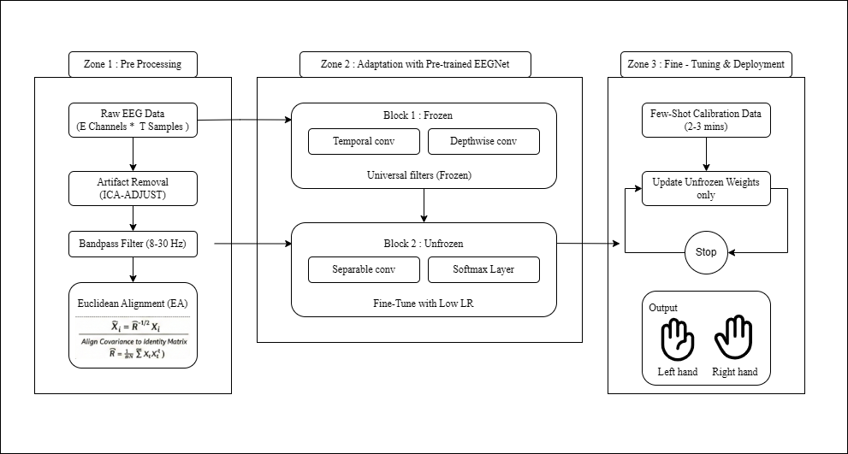
Figure 5 : Top-Level Architecture of the Proposed System
Figure 5 shows the top-level architecture of the proposed EA-FT EEGNet system in three zones. Zone 1 preprocesses raw multi-channel EEG through artifact removal, 8–30 Hz bandpass filtering, and Euclidean Alignment. Zone 2 uses a pre-trained EEGNet where early temporal and depthwise layers stay frozen, while later separable convolution and softmax layers remain trainable. Zone 3 fine-tunes only those unfrozen layers with a few minutes of calibration data and outputs left-hand or right-hand motor imagery predictions.

5.3.1 Preprocessing Module (Zone 1)
This module is responsible for cleaning and standardizing the incoming physiological signals before they reach the predictive model.
- Artifact Removal: Raw multi-channel EEG data is passed through an Independent Component Analysis (ICA) module utilizing the ADJUST algorithm. This step automatically identifies and removes stereotypic artifacts such as eye blinks (EOG) and muscle noise (EMG).
- Bandpass Filtering: The cleaned signal is filtered between 8 Hz and 30 Hz. This specific range isolates the mu and beta frequency bands, which contain the critical Event-Related Desynchronization (ERD) features associated with motor imagery.
- Euclidean Alignment (EA): This is the core mathematical extension. The EA module normalizes the spatial covariance of the incoming trials. For a set of trials Xi, the reference covariance matrix $\overline{R}$ is computed and used to align the data to an identity matrix I:
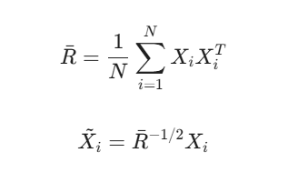

This unsupervised step ensures that the marginal distribution shift is mitigated before feature extraction.

5.3.2 ML Engine (Zone 2 - Adaptation with Pre-trained EEGNet)
The Machine Learning engine utilizes a pre-trained EEGNet architecture divided into two distinct functional blocks:
- Block 1: Universal Filters (Frozen): This block contains the initial Temporal Convolution and Depthwise Convolution layers. During the adaptation phase, the weights in this block are strictly frozen. Because they were pre-trained on a massive multi-subject dataset, they act as universal feature extractors capable of identifying fundamental brain rhythms common to all humans.

- Block 2: User Adaptation (Unfrozen): This block consists of the Separable Convolution layer and the final dense SoftMax classification layer. These layers are left unfrozen. Their purpose is to learn the unique mixing logic and execution patterns specific to the new target user.

5.3.3 Extended module (Zone 3 - Fine-Tuning & Deployment)
This module governs the operational state of the BCI system.
- Few-Shot Calibration: The system enters a brief calibration phase (2–3 minutes) where the new user performs a minimal set of MI tasks. This small dataset is passed through Zone 1 and Zone 2.

- Weight Updating: Using a low learning rate (e.g.,$5 × {10}^{-5}$), the system backpropagates the error only through the unfrozen weights of Block 2.

- Deployment (Inference): Once the few-shot update loop stops, the model transitions into real-time deployment, outputting discrete classifications (e.g., Left hand vs. Right hand intent) based on the user's continuous EEG stream.

5.4 Data Flow and Interaction Design
The data flow is designed for low-latency sequential processing.
- Input: A continuous EEG stream is windowed into discrete trials, forming an E$×$T matrix (where E is the number of electrodes and T is the number of time samples).
- Transformation: In Zone 1, the E$×$T matrix undergoes temporal filtering and spatial whitening, resulting in a statistically normalized $\overline{X}$i matrix of the same dimensions.
- Feature Extraction: As $\overline{X}$i passes through Block 1, it is transformed into a high-dimensional feature map representing generic spatial-spectral features.
- Classification: Block 2 reduces this feature map down to a 1D probability vector using SoftMax, where each element corresponds to the likelihood of a specific motor intent class.

5.5 Extension Integration into AI Framework
The EA-FT EEGNet is designed to operate within a standard deep learning backend like PyTorch or TensorFlow [6]. To integrate this into a functional BCI loop, the architecture relies on a buffering system. A real-time data streaming protocol (such as Lab Streaming Layer - LSL) pushes raw EEG data into a software buffer. The Python-based AI framework pulls from this buffer in fixed temporal epochs (e.g., 2-second windows), executes the Zone 1 and Zone 2 pipelines, and pushes the resulting SoftMax classification to an external application (e.g., a robotic interface or computer cursor) with a latency of less than 100 milliseconds.

5.6 Summary
This chapter provided a comprehensive breakdown of the EA-FT EEGNet architecture. By logically separating the system into three distinct zones global preprocessing with Euclidean Alignment, a bifurcated ML engine with frozen/unfrozen blocks, and a dedicated fine-tuning module ensures robust performance. This modular approach effectively mitigates inter-subject variability, protecting generalized features while allowing for rapid, data-efficient adaptation to new users.

CHAPTER 6

IMPLEMENTATION

6.1 Introduction
This chapter details the practical realization of all three zones of the EA-FT EEGNet framework [8], [21]: the global preprocessing and alignment pipeline (Zone 1), the source-domain pre-training of the compact convolutional network (Zone 2), and the few-shot fine-tuning, evaluation and deployment layer (Zone 3). It translates the theoretical design of Chapter 5 into a functional, programmatic environment, documenting the software and hardware platforms used, the algorithmic logic applied to signal transformation, the architectural construction and adaptation of the deep learning model, and the experimental protocol that guarantees an unbiased evaluation.

6.2 Overall Development Environment
The project was implemented in an interactive Jupiter Notebook environment, allowing for iterative execution and immediate visualization of physiological signal transformations. The codebase is heavily modularized, structured to first load and explore raw .mat files from the BCI Competition IV 2a dataset, followed by sequential signal processing functions, and culminating in an object-oriented deep learning pipeline. Reproducibility was strictly enforced by setting global random seeds (SEED = 42) across the standard library, NumPy, and PyTorch backend engines.

6.3 Hardware and Software Platforms
The development, implementation, and pre-training phases of the proposed framework were executed on a high-performance workstation equipped with an NVIDIA RTX 4050 Graphics Processing Unit (GPU). To maximize computational efficiency and significantly reduce processing time, PyTorch's native CUDA device configuration was explicitly leveraged. This hardware acceleration was critical for optimizing the heavy matrix multiplications and tensor operations inherent in deep neural network training. The software ecosystem was built entirely upon Python 3.10 as the core programming language. At the heart of the machine learning pipeline, PyTorch (v2.x) was utilized to construct the compact EEGNet architecture, define custom dataset loaders for efficient batch processing, and execute the gradient descent optimization. For rigorous signal processing and mathematical transformations, the SciPy library (scipy.signal and scipy.linalg) was heavily employed. This facilitated the implementation of zero-phase Butterworth bandpass filtering, Welch's power spectral density (PSD) estimations, and the eigen decomposition required for Euclidean Alignment. Additionally, NumPy and Pandas served as the foundational tools for managing the dataset, enabling complex multidimensional array slicing, data manipulation, and the generation of statistical summaries. Finally, the visual analysis of the electrophysiological data including the rendering of raw EEG traces, pre- and post-alignment covariance heatmaps, and model training curves was facilitated through the integration of the Matplotlib and Seaborn visualization libraries.

6.4 Module-wise Implementation

6.4.1 Data Acquisition and Parsing
The implementation began by parsing the BCI Competition IV Dataset 2a (.mat) structures. A custom load_subject function was written to iterate over the dataset, extract the 22 EEG channels (discarding EOG), and slice the continuous recordings into discrete 4-second trials (1000 samples per trial at 250 Hz) using a pre-defined cue offset. For the binary classification scope, the four original classes were filtered and remapped strictly to Left Hand (Class 0) and Right Hand (Class 1). A further quantity was extracted directly from the raw recordings: the true wall-clock cost of a single trial. The analysis window used by the network is four seconds long, but each cued trial in the Graz protocol occupies a complete acquisition cycle of fixation cross, cue presentation, motor-imagery execution and inter-trial rest. Rather than assuming this duration, the `load subject` function was extended to retain the per-run trial-onset sample indices, and the median spacing between consecutive onsets was computed across all runs of all nine subjects (2,538 intervals in total). The measured cadence is 8.03 seconds of recording time per trial. Every calibration-duration figure reported in this thesis is derived from this measured value rather than from the four-second analysis window, so that the reported calibration times reflect the real burden experienced by a new user.
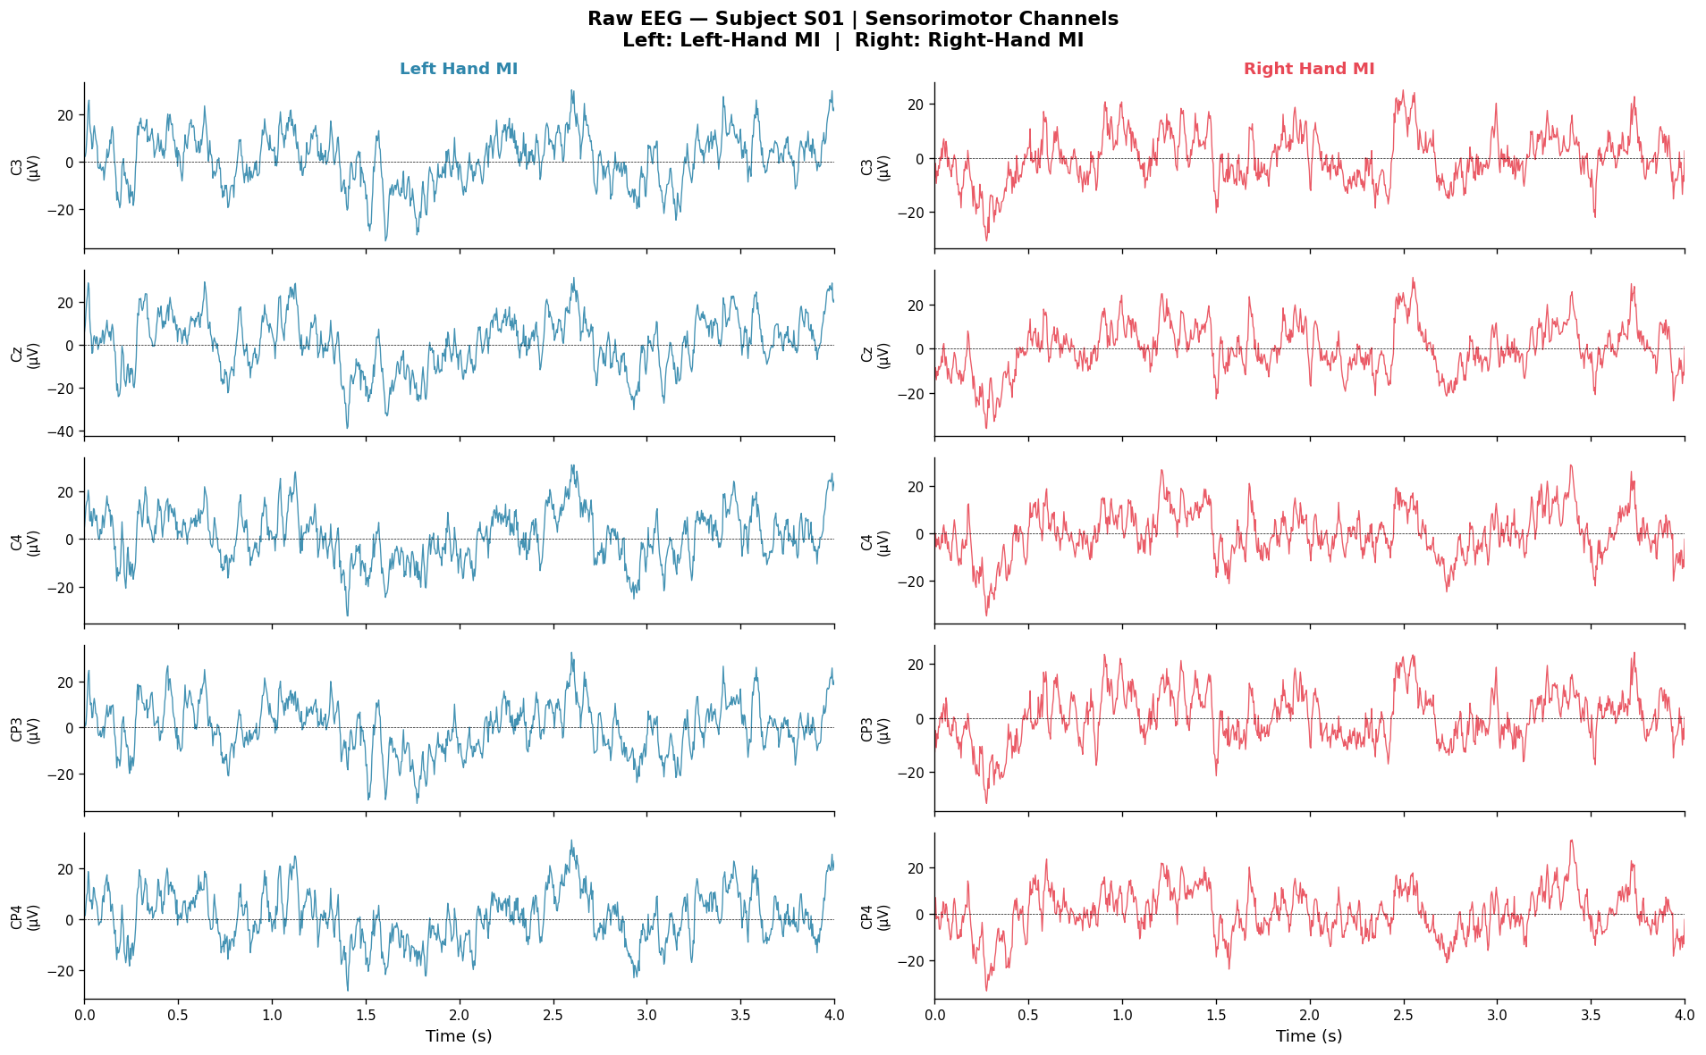
Figure 6 : Raw EEG time-series traces for Left- and Right-Hand motor imagery
Figure 6 shows raw EEG time-series traces from subject S01 for left-hand (blue) and right-hand (red) motor imagery across five sensorimotor channels (C3, Cz, C4, CP3, and CP4) over a 4-second window. The signals appear noisy and visually similar between classes, which indicates that reliable left/right discrimination usually needs further processing such as filtering and feature learning.
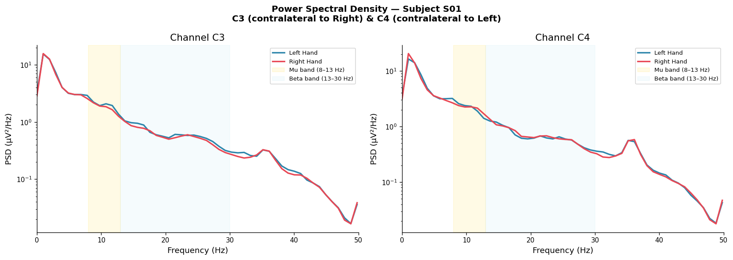
Figure 7 : Power Spectral Density (PSD) comparison showing mu and beta ERD.
Figure 7 shows the Power Spectral Density (PSD) comparison for subject S01 at channels C3 and C4 during left-hand (blue) and right-hand (red) motor imagery. The shaded regions mark the mu (8–13 Hz) and beta (13–30 Hz) bands, where contralateral Event-Related Desynchronization (ERD) appears as reduced power right-hand imagery lowers power at C3, while left-hand imagery lowers power at C4.

6.4.2 Artifact Removal (Zone 1)
To simulate the behavior of ICA-ADJUST within the automated Python pipeline, a variance-based artifact rejection algorithm was implemented. The function calculates the peak-to-peak amplitude for every trial and rejects those exceeding a dynamically calculated threshold of 5$σ$ from the global mean, effectively scrubbing extreme muscular or ocular noise.

6.4.3 Bandpass Filtering (Zone 1)
A zero-phase, 4th-order Butterworth bandpass filter was programmed using scipy.signal.butter and filtfilt. The cutoff frequencies were strictly bound between 8 Hz and 30 Hz to isolate the critical mu and beta Event-Related Desynchronization (ERD) features.
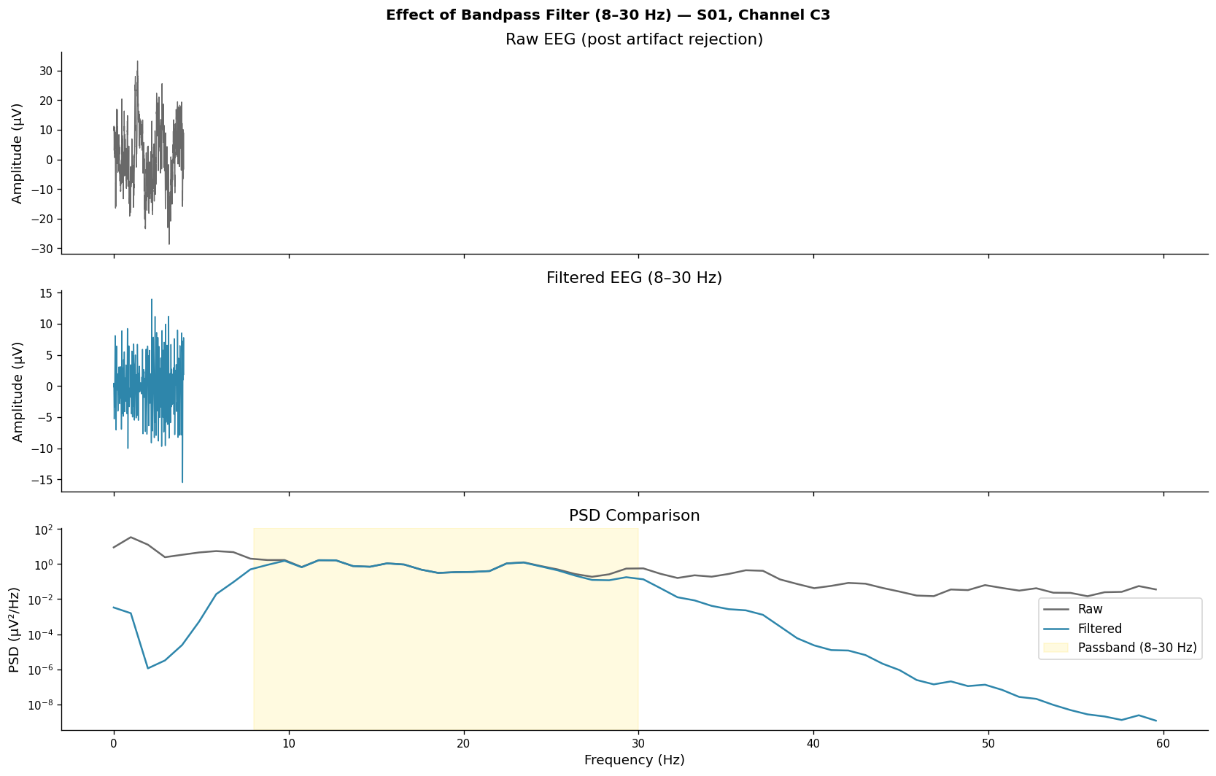
Figure 8 : EEG signals before and after 8–30 Hz Butterworth bandpass filtering.
Figure 8 shows the effect of 8–30 Hz Butterworth bandpass filtering on subject S01, channel C3. The top plot is the raw EEG after artifact rejection, the middle plot is the filtered signal, and the bottom PSD comparison shows that power outside the mu/beta passband is strongly attenuated while the 8–30 Hz content is preserved.

6.4.4 Euclidean Alignment (Zone 1)
The core mathematical extension, Euclidean Alignment (EA), was implemented using NumPy's linear algebra module. For each subject's dataset matrix X, the mean covariance matrix $\overline{R}$ was computed. To ensure numerical stability before inversion, a small identity matrix regularization term (1 $×{10}^{-8}$) was added. The inverse square root of this matrix ($\overline{R^{-1/2}}$) was derived via eigen decomposition and applied to all trials via np.einsum to achieve spatial whitening.
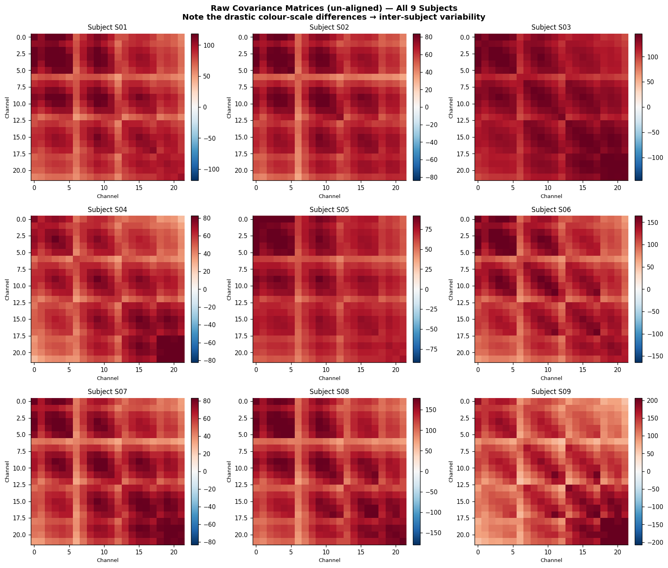
Figure 9 : Raw spatial covariance matrices for all nine subjects.
Figure 9 shows the raw spatial covariance matrices for all nine subjects before alignment. Each heatmap represents channel-to-channel covariance, and the large differences in colour scale across subjects highlight strong inter-subject variability in EEG spatial statistics.
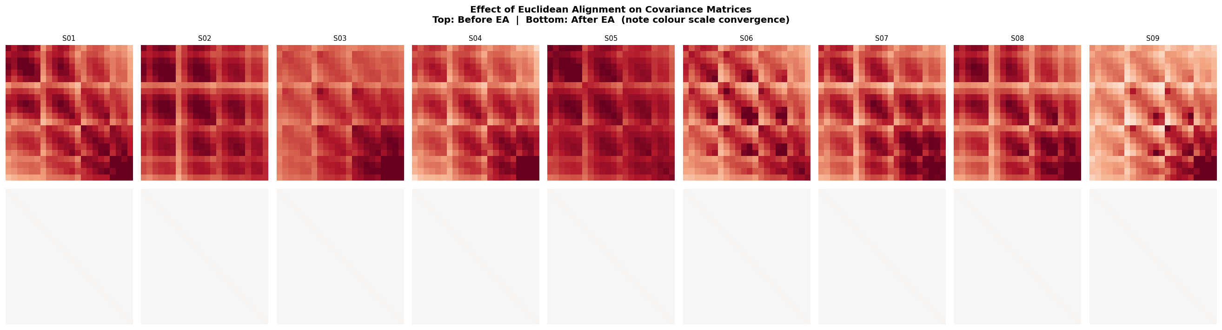
Figure 10 : Covariance matrices before (top) and after (bottom) Euclidean Alignment.
Figure 10 shows covariance matrices for all nine subjects before (top) and after (bottom) Euclidean Alignment. Before EA, the matrices differ strongly across subjects; after EA, their colour scales converge, indicating that spatial statistics are mapped into a more comparable common space for cross-subject transfer.

6.4.5 EEGNet Architecture & Pre-training (Zone 2)
The compact EEGNet was programmed as a PyTorch nn.Module. It was explicitly divided into self. block1 (Temporal and Depthwise Convolutions) and self.block2 (Separable Convolutions and Classifier). Helper methods like freeze_block1() and unfreeze_block2() were coded directly into the class to handle gradient tracking requires_grad = False/True. A Leave-One-Subject-Out (LOSO) cross-validation loop was implemented to train the source model. For a given target subject, all other subjects' aligned data were pooled, shuffled, and fed into a PyTorch DataLoader. The model was trained using the Adam optimizer with a Cosine Annealing Learning Rate scheduler over 50 epochs.

6.4.6 Deployable Euclidean Alignment (Zone 1, revised)
The Euclidean Alignment procedure described in section 6.4.4 estimates the reference covariance matrix from the complete set of trials belonging to a subject. While this is the formulation presented by He and Wu and is entirely adequate for offline analysis, it is transductive: the reference matrix is informed by trials that will subsequently be used to evaluate the model. A brain–computer interface operating in real time cannot behave in this way, because at the moment of calibration the trials the user will produce later in the session do not yet exist. Reporting accuracies obtained under a transductive alignment would therefore risk an unquantified degree of optimism. To eliminate this concern rather than merely acknowledge it, the alignment module was refactored so that both a transductive and a strictly causal formulation could be executed and compared.
The original routine, euclidean_alignment(X), was retained unchanged and performs the transductive computation. It accepts the full trial tensor of a subject, accumulates the second-moment matrix R̄ = (1/N)·Σ Xᵢ Xᵢᵀ across every trial, regularises it by the addition of 10⁻⁸ I to guarantee invertibility, derives the inverse square root R̄ through the symmetric eigen decomposition provided by numpy.linalg.eigh, and applies the resulting transformation to every trial by Einstein summation. Eigenvalues are floored at 10⁻¹⁰ before the negative-half-power is taken, which prevents a numerically degenerate channel from producing an unbounded scaling factor.
The second formulation decomposes the same mathematics into two independent operations, so that estimation and application no longer occur on the same data. The function ea_fit(X) performs only the estimation stage: it computes the mean second-moment matrix over whatever set of trials it is supplied with, applies the identical regularization and eigen decomposition, and returns the whitening matrix P = R̄^(−1/2) as a 22 × 22 array. The function ea_apply(P, X) performs only the application stage, projecting an arbitrary tensor of trials through a previously estimated and fixed whitening matrix by means of the expression np.einsum('cd,ndt -> nct', P, X). Because the two stages are separated, the matrix estimated at one point in time may be applied unchanged to data acquired at any later point.
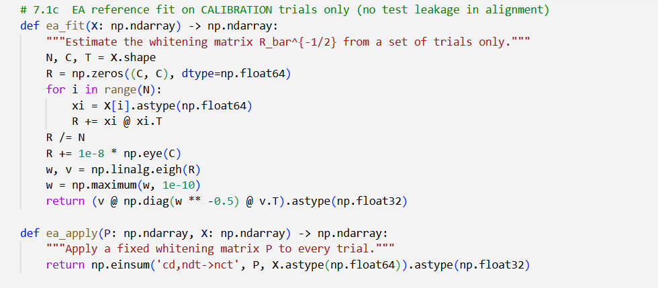
Figure 11: Deployable Euclidean Alignment — Reference Estimation and Fixed Application
This separation is what makes the deployable protocol possible. In that protocol, ea_fit is invoked once, on the thirty-six calibration trials alone. The matrix it returns is then frozen and applied by ea_apply to those same calibration trials and, without further modification, to every subsequent trial the subject produces. No test trial contributes to the estimate of the whitening transformation, and the procedure is causally realisable: it corresponds exactly to a live system that records a short calibration block on the user's arrival, computes a whitening matrix from it, and thereafter whitens each incoming trial as it is received. This transformation costs a single 22 × 22 matrix multiplication per trial and therefore imposes no measurable latency during operation.
Both formulations were carried out through the complete experimental pipeline. The transductive variant is used internally in the ablation study of section 7.7.7, where every experimental arm must share an identical alignment convention for the comparison between arms to be meaningful. The calibration-only variant provides the deployable result reported as the primary outcome of this research. Implementing both permitted the difference between them to be measured directly rather than assumed, and the analysis presented in section 7.7.6 establishes that the framework carries no transductive optimism whatsoever.

6.4.7 Zone 3 — Few-shot fine-tuning with leakage-free model selection
The final zone of the framework was implemented as the function fine_tune(), which performs the rapid adaptation of a pre-trained source model to a new target user. The routine begins by taking a deep copy of the supplied source model through copy.deepcopy, so that the pre-trained weights are never modified in place and the same source model may subsequently be reused by other experimental arms without contamination. The transfer-learning state is then established by invoking the two methods built into the model class: freeze_block1() disables gradient tracking on the temporal convolution, depthwise convolution and their associated batch-normalisation layers, locking 912 parameters, while unfreeze_block2() guarantees that the separable convolution block and the dense classifier remain trainable, giving 1,538 adaptable parameters.
Optimisation is performed by an Adam optimiser constructed over filter(lambda p: p.requires_grad, model.parameters()), so that the frozen tensors are excluded from the optimiser's parameter group entirely rather than merely receiving zero gradients. The learning rate is set to 5 × 10⁻⁵, twenty times lower than the rate used during source-domain pre-training, with a weight decay of 1 × 10⁻⁴. This deliberate conservatism is the mechanism by which the framework guards against catastrophic forgetting: the adaptation is permitted to refine the user-specific mixing logic but not to overwrite it. Training proceeds in mini batches of at most sixteen trials for a maximum of thirty epochs, with gradient norms clipped at unity, and terminates early once ten consecutive epochs have failed to improve the selection criterion.
The most consequential design decision in this routine concerns how the stopping epoch and the final checkpoint are chosen. A helper function, _val_split_from_calib(), partitions the calibration trials into a fine-tuning portion and a validation portion in a 75: 25 ratio using a subject-specific seeded random state. The function additionally verifies that both classes are represented in each partition and falls back to a label-ordered split in the rare event that a purely random permutation would leave one partition class-degenerate. At the end of every epoch the model is evaluated on this validation partition, and a composite score consisting of validation accuracy with a small tie-breaking contribution from validation AUC determines whether the current weights are checkpointed and whether the patience counter is reset or incremented. When the loop terminates, the best checkpoint is restored and the held-out test trials are loaded and scored exactly once, yielding the accuracy, area under the ROC curve and Cohen's kappa reported in Chapter 7.
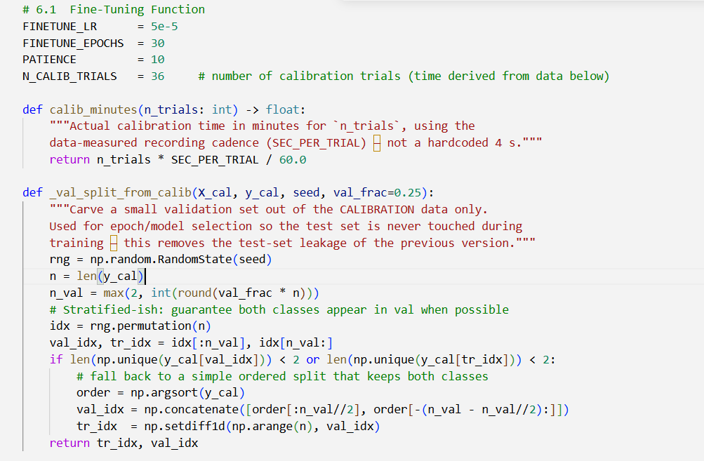
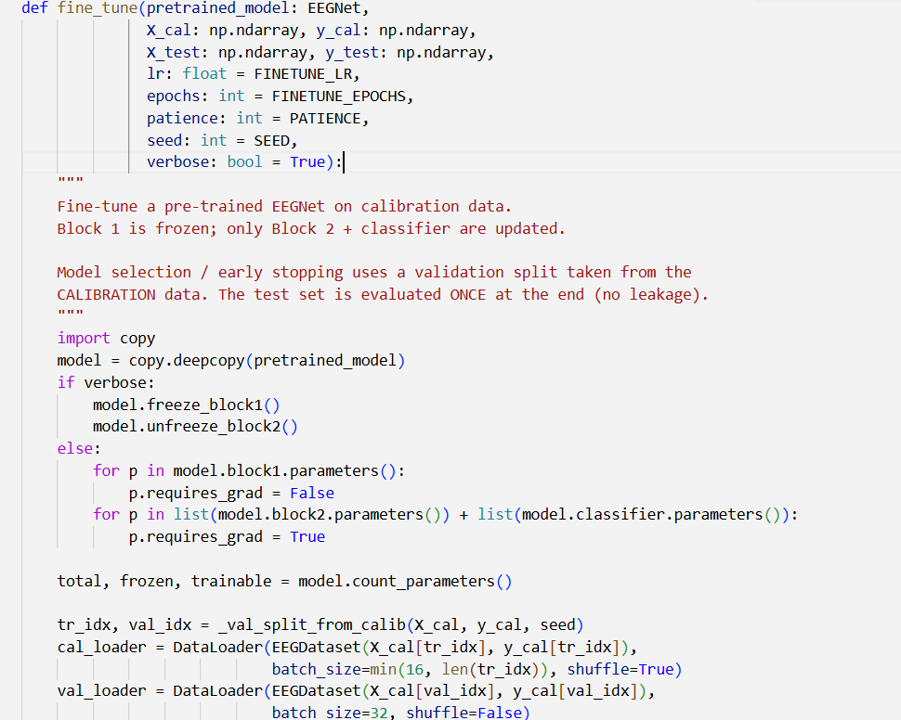
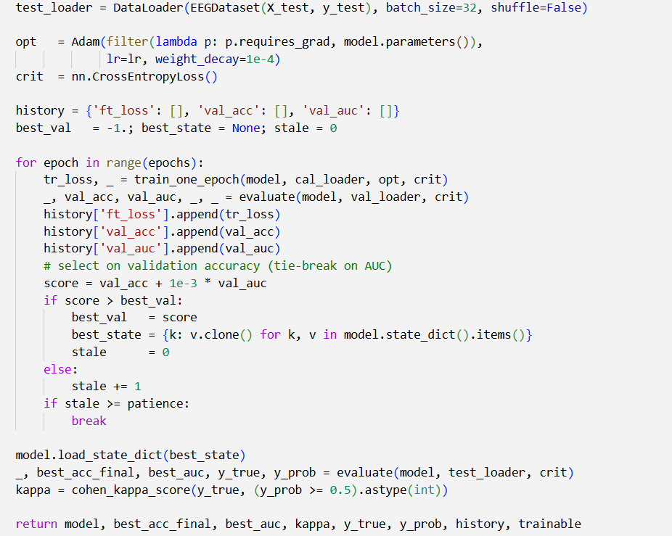
Figure 12: Leakage-Free Few-Shot Fine-Tuning with Calibration-Based Model Selection
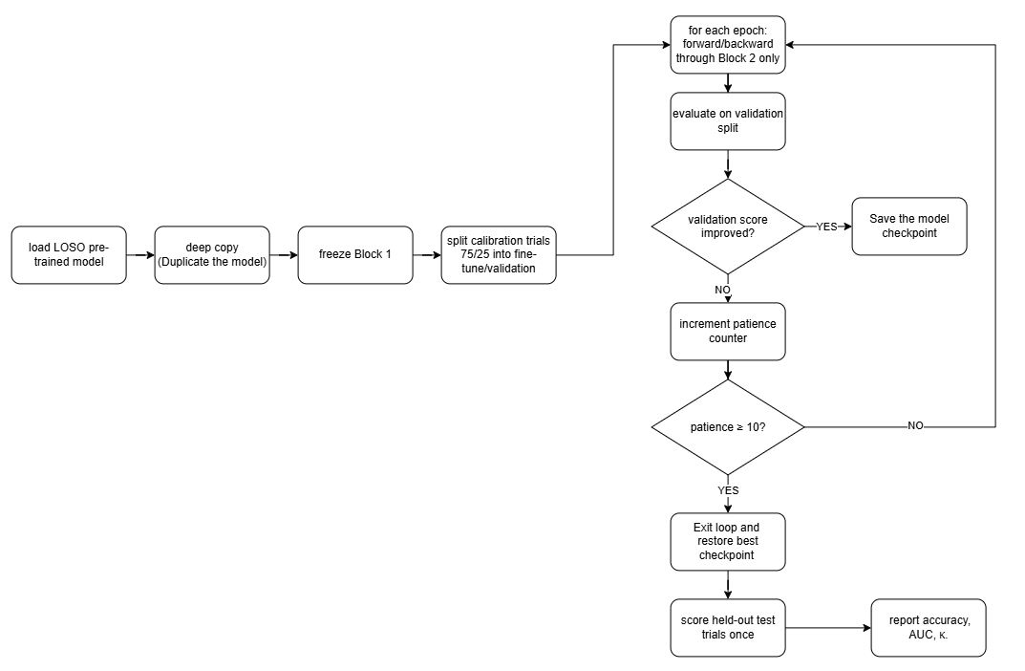
Figure 13: Zone 3 Few-Shot Fine-Tuning and Evaluation Loop
Figure 13 shows the Zone 3 few-shot fine-tuning and evaluation loop. A LOSO pre-trained model is loaded, Block 1 is frozen, and calibration trials are split 75/25 for fine-tuning and validation. Only Block 2 is updated each epoch, with early stopping after 10 non-improving validations; the best checkpoint is then scored once on held-out test trials using accuracy, AUC, and Cohen’s kappa.
This protocol replaced an earlier prototype in which the stopping epoch had been selected by monitoring accuracy on the test set. Although superficially reasonable, that arrangement constitutes test-set leakage: the reported figure becomes the accuracy of the best of thirty checkpoints as judged on the very data reserved to measure generalisation, which is a quantity no deployed system can attain, since a deployed system has no access to the labels of the trials it is about to classify. Every result presented in this thesis was regenerated under the corrected protocol. The accuracies obtained are lower than those of the earlier prototype, and they are correspondingly more trustworthy: they are the accuracies a genuine user would experience.

6.4.8 Implementation of the ablation arms
Establishing that the complete framework performs well would demonstrate only that the system works, not which of its components is responsible. Three additional experimental conditions were therefore implemented so that the contribution of each component could be isolated and attributed.
The first condition, implemented as train_from_scratch(), establishes the performance floor. A fresh EEGNet is instantiated with random weights and trained exclusively on the target subject's thirty-six calibration trials, with no transfer of knowledge from any other subject. Because no pre-trained representation exists to be protected, the learning rate is raised to 1 × 10⁻³, matching the pre-training configuration, and no layer is frozen. In every other respect the validation split, the early-stopping rule, the checkpoint criterion and the single-scoring of the test set the procedure is identical to fine_tune(), so that the comparison isolates the effect of transfer learning alone and is not confounded by differences in training protocol.
The second condition, zero-shot transfer, requires no additional training. The LOSO pre-trained source model is passed directly to the evaluation routine and scored on the target subjects held-out trials without any weight update whatsoever. This measures how much of the source population's knowledge transfers to a new individual in the complete absence of personalization.
The third condition, fine-tuning without Euclidean Alignment, is the control that isolates the alignment stage, and it required the most substantial additional computation. An entire parallel Leave-One-Subject-Out pre-training run was executed on dataset_noea, the band-pass-filtered but un-aligned counterpart of the aligned dataset, producing a second complete set of nine source models. Each of these was then adapted to its target subject using the same fine_tune() routine, the same learning rate, the same freezing strategy and the same early-stopping rule, differing from the proposed framework in one respect only: the absence of spatial whitening at the input.
A methodological safeguard binds these four conditions together and is essential to the validity of the statistical analysis in Chapter 7. For each target subject, the trial ordering is generated by a deterministic permutation seeded as RandomState(SEED + subject_id), and this identical permutation is regenerated inside every experimental arm rather than being drawn afresh. Consequently, the same thirty-six trials serve as calibration data and the same remaining trials serve as test data in all four conditions, for every subject. The four accuracy figures obtained for a given subject are therefore genuinely paired observations of the same underlying data, which is precisely the condition required for the paired Wilcoxon signed-rank tests reported in section 7.7.10 to be applicable.

6.4.9 Persistence of the adapted models
The final implementation stage concerns the serialization of the completed system, so that a subject-adapted model may be reloaded and used for inference without repeating any stage of training. Three categories of object are written to disk for each of the nine target subjects. The first is the fine-tuned network itself. The state dictionary of each adapted model is detached from the computation graph, transferred to CPU memory and stored, accompanied by a record of the architectural hyper-parameters the number of classes, channels and time samples, together with the filter counts F₁, D and F₂ and the temporal kernel length so that the network can be reconstructed exactly without reference to the original source code. The second is the calibration-only whitening matrix produced by ea_fit, retained as a 22 × 22 single-precision arrays; this is the entire persistent state of the alignment stage, and storing it is what allows Zone 1 to be reproduced at inference time without access to the calibration recordings. The third is the recording metadata required to construct a valid input tensor: the ordered list of the twenty-two channel names, the sampling rate of 250 Hz, the trial length of 1,000 samples, the class label mapping, and the measured acquisition cadence of 8.03 seconds per trial. The practical consequence of this design merits emphasis. The nine subject-adapted models together occupy 146 kilobytes, a figure that follows directly from the compactness of the EEGNet architecture: at 2,450 parameters per model, the entire deployed system is smaller than a single high-resolution photograph. Inference on one trial consists of a single 22 × 22 matrix multiplication to apply the stored whitening transformation, followed by one forward pass through the 2,450-parameter network. Both operations execute in real time on a standard laptop central processing unit, with no requirement for graphics acceleration at deployment time; the GPU is needed only for the offline pre-training stage. This substantiates the claim advanced in section 5.5 that the framework can operate within a latency budget of the order of one hundred milliseconds, and it confirms that the computational profile of the system is compatible with embedded or portable assistive hardware rather than being confined to the workstation on which it was developed.

6.5 Algorithms and Pseudocode
This section details the exact programmatic logic and Python algorithms implemented to execute the core mathematical and architectural transformations of the EA-FT EEGNet framework. The codebase heavily utilizes NumPy for linear algebra and array manipulation, SciPy for signal processing, and PyTorch for neural network operations.

6.5.1 Variance-Based Artifact Rejection
Before filtering, extreme artifacts (such as eye blinks and muscle twitches) must be removed to prevent them from corrupting the spatial covariance matrices. Because a full independent component analysis (ICA) requires offline MATLAB processing, an automated variance-based thresholding algorithm was implemented for the Python pipeline.
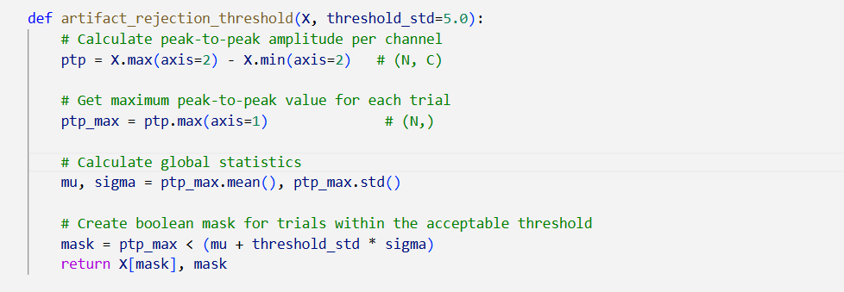
Figure 14 : Variance-Based Artifact Rejection
The algorithm computes the peak-to-peak (maximum minus minimum) amplitude for every trial across all channels. It then calculates the global mean $μ$ and standard deviation $σ$ of these maximum amplitudes. Any trial containing an amplitude that exceeds $μ$ + 5$σ$ is flagged as an artifact and removed from the dataset.

6.5.2 Zero-Phase Bandpass Filtering
To extract the relevant neurophysiological signals associated with Motor Imagery, the raw EEG data must be restricted to the mu and beta frequency bands. The algorithm utilizes a 4th-order Butterworth bandpass filter. It is implemented using scipy.signal.filtfilt to apply a zero-phase forward and backward pass, ensuring that no artificial phase delays are introduced into the temporal EEG data. The cutoff frequencies are strictly set between 8.0 Hz and 30.0 Hz.
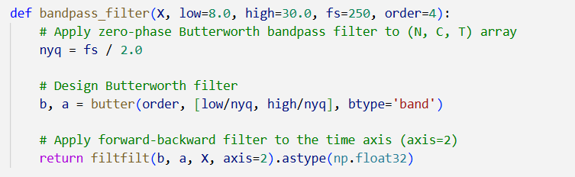
Figure 15 : Zero-Phase Bandpass Filtering

6.5.3 Euclidean Alignment (Spatial Whitening)
This algorithm represents the core mathematical contribution of the preprocessing pipeline. It normalizes the spatial covariance across different subjects to mitigate marginal distribution shifts.
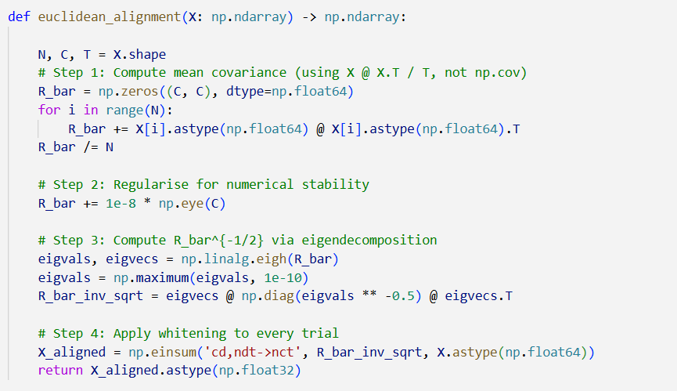
Figure 16 : Euclidean Alignment (Spatial Whitening)
The algorithm iterates through all trials for a single subject to calculate the mean covariance matrix $\overline{R}$ To ensure the matrix is invertible, a small identity matrix (1 $×{10}^{-8}$) is added for numerical stability. The inverse square root ($\overline{R^{-1/2}}$) is calculated using eigendecomposition (np.linalg.eigh). Finally, Einstein summation (np.einsum) is used to efficiently multiply this transformation matrix against every trial in the dataset, effectively whitening the spatial distribution.

6.5.4 Layer-Freezing Logic for Network Adaptation
To enable the proposed Transfer Learning methodology, the PyTorch implementation of the EEGNet model must dynamically alter which layers are permitted to update their weights during the gradient descent backward pass.
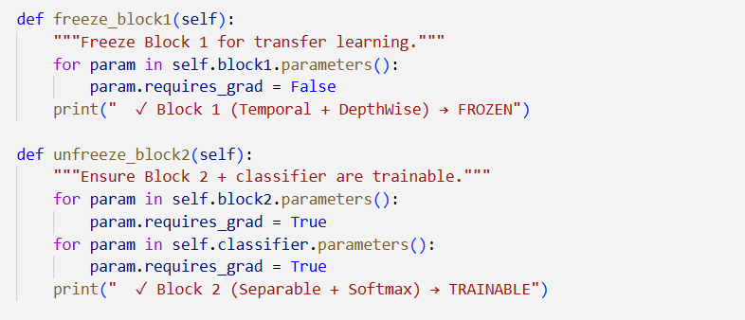
Figure 17 : Layer-Freezing Logic for Network Adaptation
The network's architectural components were explicitly separated during the __init__ phase into self.block1 and self.block2. Two specific methods were implemented within the model class to manipulate PyTorch's requires_grad attribute. The freeze_block1 method disables gradient tracking for the universal filters, locking their pre-trained state. Conversely, unfreeze_block2 ensures the user-specific adaptation layers remain active for optimization.

6.6 Workflow Diagrams / Flowcharts
Figure 18 illustrates the sequential data flow for the signal preprocessing phase. The pipeline begins by extracting the 22 relevant EEG channels from the raw .mat files and epoching the continuous data into discrete trials. A decision node represents the variance-based artifact rejection algorithm; trials exceeding the 5$σ$ peak-to-peak threshold are discarded. The surviving clean trials are passed through a 4th-order Butterworth bandpass filter. Finally, the flowchart details the step-by-step matrix operations required to execute Euclidean Alignment, transforming the heterogeneous spatial covariance of the subject into a standardized, identity-aligned tensor ready for neural network ingestion.
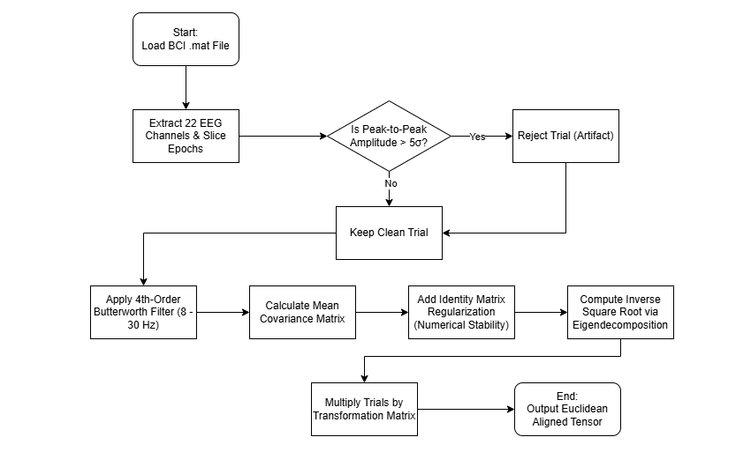
Figure 18 : Zone 1 Preprocessing and Euclidean Alignment Pipeline
Figure 18 maps the algorithmic logic of the source-model pre-training phase. The flowchart outlines the Leave-One-Subject-Out (LOSO) cross-validation strategy, where data from a selected target subject is isolated, and the model is initialized using the pooled data of the remaining subjects. The core loop illustrates the gradient descent process across 50 epochs, detailing the forward pass-through Blocks 1 and 2, loss calculation, and the backward pass. A critical decision node evaluates the validation accuracy at the end of each epoch, triggering a checkpoint mechanism to save the optimal model weights before concluding with a zero-shot evaluation on the unseen target subject.

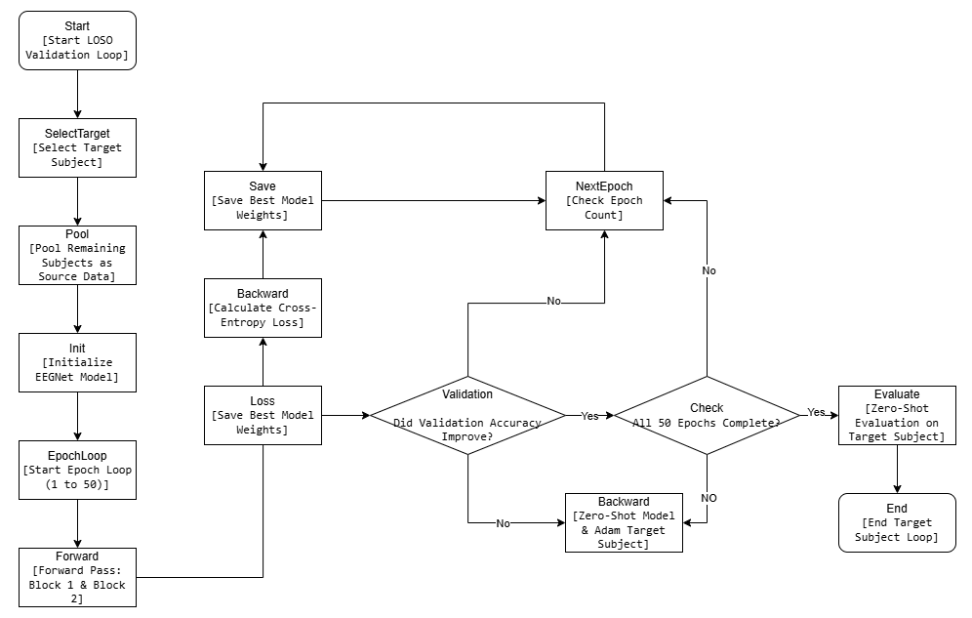
Figure 19 : Leave-One-Subject-Out (LOSO) Pre-training Loop

6.7 Integration of Components
The integration between the mathematical preprocessing (Zone 1) and deep learning operations (Zone 2) was bridged using a custom PyTorch EEGDataset class. Once numpy arrays were fully aligned and filtered, they were converted into torch.Tensor objects. This allowed the pre-processed data to natively interface with PyTorch's DataLoader, enabling automated batching (batch size of 32), shuffling, and device management (pushing tensors to the GPU) seamlessly during the training loop.

6.8 Testing During Development
Rigorous sanity checks were executed throughout the development pipeline:
- Dimensionality Checks: After instantiating the EEGNet class, a dummy tensor of shape (8, 22, 1000) was passed through the forward method to dynamically compute the flattening size and verify that no matrix mismatches occurred.
- Parameter Verification: A custom `count_parameters()` function was written to assert the exact split of the network's 2,450 parameters when the transfer-learning state is applied. Block 1 (temporal convolution, depthwise convolution and their batch-normalization layers) accounts for 912 frozen parameters (37.2 % of the network), while Block 2 (separable convolution, batch normalization) together with the dense classifier accounts for 1,538 trainable parameters (62.8 %). This assertion was executed after every call to `freeze_block1() ` to guarantee that the gradient-tracking state had actually been altered and that no parameter had silently remained trainable.
- Visual Validation: Signal integrity was constantly tested by plotting spectrograms and Power Spectral Densities (PSDs) before and after filtering to physically verify that the expected MI features were preserved.

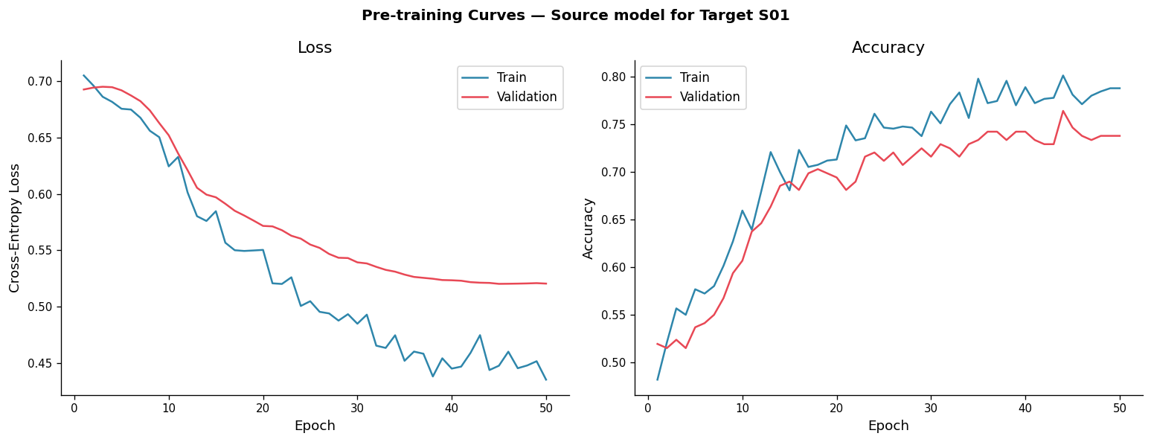
Figure 20 : Model convergence during Leave-One-Subject-Out pre-training.
Figure 20 shows model convergence during Leave-One-Subject-Out pre-training for target subject S01. Training and validation loss both decrease over 50 epochs, while accuracy rises, with validation accuracy peaking near 0.76; the later gap between train and validation curves indicates mild overfitting on the source subjects.

6.9 Summary
This chapter outlined the successful implementation of data acquisition, preprocessing, and source-model training phases. By utilizing Python and PyTorch, raw heterogeneous brain signals were successfully parsed, cleaned, and geometrically aligned using the Euclidean Alignment algorithm. The compact EEGNet architecture was effectively established and pre-trained using a cross-subject validation strategy, confirming that the programmatic foundation of the system is stable and operationally functional.

CHAPTER 7

EVALUATION

7.1 Introduction
The preceding chapter established that the EA-FT EEGNet framework had been successfully implemented as a functioning software system. Demonstrating that a system executes without error is, however, an entirely different matter from demonstrating that it works, and it is different again from demonstrating that the specific mechanism the research proposes is the mechanism responsible for whatever performance is observed. This chapter is concerned with the second and third of those questions. The evaluation reported here pursues four distinct aims. The first is to verify that the Euclidean Alignment module performs the geometric operation it was designed to perform, namely the removal of inter-subject covariance mismatch, and to quantify that removal with an objective metric rather than by visual inspection of heat maps alone. The second is to measure the end-to-end classification performance of the complete framework on a recognised benchmark, using metrics that remain informative for a two-class problem and reporting per-subject results rather than only an aggregate that could conceal wide variability. The third, and the most important scientifically, is to decompose that performance through a controlled ablation so that the individual contribution of each component to the alignment stage, the transfer of pre-trained weights, and the conservative fine-tuning stage can be separated and attributed. The fourth is to establish whether the framework achieves the practical objective that motivated the entire research, namely a substantial reduction in the calibration burden imposed on a new user, and to determine the point at which additional calibration data ceases to buy additional accuracy.
A deliberate methodological commitment underlies the whole chapter. Every result is reported under a protocol in which the held-out test trials are used exactly once, at the end, purely for scoring. Model selection, early stopping and every hyper-parameter decision are driven by data carved out of the calibration set. An earlier version of this work selected the best fine-tuning epoch by monitoring test accuracy, which is a form of test-set leakage that inflates reported performance without improving the deployed system at all. That protocol was discarded and every number in this chapter was regenerated under the corrected one. The accuracies reported here are consequently lower than those of the earlier prototype, and they are the accuracies a real user would actually experience.
The chapter proceeds by first setting out the evaluation strategy and the experimental configuration, then describing the dataset and the test cases derived from it, then defining the metrics. The results are then presented in a sequence that mirrors the data flow of the system itself: alignment quality, source-model transfer, few-shot adaptation, deployment-realistic alignment, ablation, isolation of the alignment effect, calibration-size sensitivity, and statistical significance. A comparison with published methods and a critical discussion of the findings close the chapter.

7.2 Evaluation Strategy
The evaluation strategy was designed around a single governing constraint: the framework claims to solve a cross-subject problem, and therefore it must never be evaluated in a way that allows information about the target user to reach the model through an unintended route.
Leave-One-Subject-Out cross-validation. The primary experimental design is Leave-One-Subject-Out (LOSO) cross-validation at the subject level. For each of the nine subjects in turn, that subject is designated the target and is completely withheld from pre-training; the remaining eight subjects are pooled to form the source domain on which the EEGNet model is pre-trained from random initialization. This yields nine independent source models, each of which has never observed a single trial from the subject it will subsequently be asked to decode. This protocol reproduces the situation faced by a deployed BCI: a network trained in the laboratory on a population of previous users meets an entirely new person. Any protocol that pooled all subjects and then split trials randomly would allow the model to memorize the target's individual signal characteristics during training and would produce accuracies that are meaningless as a measure of cross-subject generalization.
The calibration/test partition. Within each target subject, the available trials are permuted once using a per-subject deterministic seed, `RandomState(SEED + subject_id) `. The first 36 trials of that permutation form the calibration set, standing for the short recording session a new user would perform on arrival. The remaining trials between 106 and 108 depending on how many trials survived artifact rejection for that subject form the test set and represent the subsequent period of real use. Because the permutation is seeded per subject and regenerated identically inside every experimental arm, all four conditions in the ablation study are evaluated on precisely the same test trials for every subject. This is what makes the comparison a genuine, paired comparison and what licenses the use of a paired statistical test in section 7.7.10.

Leakage-free model selection. Within the 36 calibration trials, a further 25 % is set aside as a fine-tuning validation split. Epoch selection, the early-stopping decision and the restoration of the best checkpoint are all driven by this validation split alone. The test trials are loaded exactly once, after the best checkpoint has been restored, and are scored a single time. No hyper-parameter, no stopping point and no architectural choice anywhere in this chapter was informed by test performance.
Ablation as the instrument of attribution. Reporting only the accuracy of the complete framework would establish that the system works but would say nothing about why. The evaluation therefore compares four conditions that differ from one another in exactly one component at a time: a from-scratch baseline with no transfer learning at all, a zero-shot condition with transfer but no adaptation, a fine-tuning condition without Euclidean Alignment, and the complete EA-FT framework. A fifth analysis isolates the alignment effect still further by comparing zero-shot transfer with and without EA, removing fine-tuning from the picture entirely so that alignment is the only variable that changes.
Statistical inference, with only nine subjects, differences of a few percentage points in a mean can easily be produced by chance. Each comparison is therefore subjected to a two-sided Wilcoxon signed-rank test on the paired per-subject accuracies, accompanied by the matched-pairs rank-biserial effect size and an explicit statement of the test's power limitations at this sample size.
Reproducibility, A global seed of 42 is applied to the Python standard library, NumPy and the PyTorch CPU and CUDA backends at the start of every run. All experimental seeds are deterministic functions of the global seed and the subject identifier, so the entire chapter can be regenerated exactly.

7.3 Experimental Setup
All experiments were executed on a single workstation equipped with an NVIDIA GeForce RTX 4050 laptop GPU, running Python 3.10.19, PyTorch 2.0.1 with CUDA 11.8 and NumPy 1.23.5. Tensor operations were dispatched to the GPU through PyTorch's native CUDA device configuration; signal-processing operations (Butterworth filtering, Welch power spectral density estimation, eigen decomposition for alignment) were executed on the CPU through SciPy and NumPy. The complete nine-fold LOSO pre-training run, the nine fine-tuning runs, the three ablation arms and the calibration-size sweep together execute in well under one hour on this hardware, which is itself a meaningful result: the entire research pipeline is reproducible on consumer-grade equipment.
The configuration of every stage of the framework is given in Table 2. Each value is stated so that the experiment can be replicated exactly.

Table 2: Experimental configuration and hyper-parameters of the EA-FT EEGNet framework
Stage | Parameter | Value | Rationale
Signal acquisition | Sampling rate | 250 Hz | Native rate of BCI Competition IV 2a
 | EEG channels retained | 22 | The three EOG channels are discarded
 | Analysis window | 4.0 s (1,000 samples) | Motor-imagery period of the Graz protocol
 | Cue offset | 1.0 s (250 samples) | Skipping the cue-evoked response, isolating sustained imagery
 | Measured acquisition cadence | 8.03 s / trial | Median inter-onset spacing over 2,538 intervals
Zone 1 : Preprocessing | Artifact rejection threshold | μ + 5σ peak-to-peak | Removes gross ocular and muscular contamination
 | Bandpass filter | Butterworth, 4th order, 8–30 Hz | Isolates the mu and beta ERD bands
 | Filter application | filtfilt (zero-phase) | Prevents phase distortion of the temporal signal
 | Alignment regularisation | 1 × 10⁻⁸ · I | Guarantees invertibility of the covariance matrix
Zone 2: Architecture | Temporal filters F₁ | 8 | EEGNet default (Lawhern et al., 2018)
 | Depth multiplier D | 2 | EEGNet default
 | Separable filters F₂ | 16 | EEGNet default
 | Temporal kernel length | 64 samples (256 ms) | Half the sampling rate; captures ≥ 4 Hz rhythms
 | Dropout rate | 0.5 | Regularisation on a small dataset
 | Total parameters | 2,450 | Two orders of magnitude below DeepConvNet
Zone 2: Pre-training | Optimizer | Adam, weight decay 1 × 10⁻⁴
 | Learning rate | 1 × 10⁻³, cosine-annealed | Aggressive on the large, pooled source set
 | Epochs | 50 | Convergence confirmed in Figure 20
 | Batch size | 32
 | Source/validation split | 80 / 20 | Checkpoint selection during pre-training
 | Gradient clipping | max norm 1.0 | Stabilizes training on noisy physiological data
Zone 3: Fine-tuning | Frozen parameters | 912 (Block 1) | Preserves universal sensorimotor filters
 | Trainable parameters | 1,538 (Block 2 + classifier) | Adapts user-specific mixing logic
 | Learning rate | 5 × 10⁻⁵ | Twenty times lower than pre-training; conservative by design
 | Maximum epochs | 30
 | Early stopping patience | 10 epochs
 | Batch size | 16 | Suited to a 27-trial fine-tuning split
 | Calibration trials | 36 (≈ 4.82 min) | Corresponds to 36 × 8.03 s of recording
 | Validation split | 25 % of calibration | Enables leakage-free model selection
Global | Random seed | 42 | Applied to random, NumPy and PyTorch

7.4 Datasets and Test Cases
All experiments use the BCI Competition IV Dataset 2a, recorded at the Institute for Knowledge Discovery, Graz University of Technology. It is the most widely used public benchmark for motor-imagery decoding and was selected precisely because its ubiquity permits meaningful comparison with published work. The dataset contains recordings from nine healthy subjects, denoted S01 to S09. Each subject performed four motor-imagery classes left hand, right hand, both feet and tongue with 72 trials per class per session, giving 288 trials per subject and 2,592 trials in total for the training session used here. Signals were recorded from 22 EEG electrodes arranged over the sensorimotor cortex according to the international 10–20 system, together with three EOG channels which are discarded in this work. The recordings are sampled at 250 Hz and were band-pass filtered between 0.5 Hz and 100 Hz with a 50 Hz notch at acquisition time.
The target task in this research is the binary discrimination of left-hand from right-hand motor imagery. This restriction is deliberate rather than a convenience. The two classes generate the most strongly lateralized and physiologically well-characterized response in the entire motor-imagery repertoire: imagined movement of one hand produces event-related desynchronization in the mu and beta bands over the contralateral sensorimotor cortex. Because discriminative information is known in advance to be spatial and lateralized, this task is the appropriate testbed for a hypothesis about spatial covariance alignment. A four-class formulation would confound the spatial alignment question with the additional difficulty of separating foot and tongue imagery, whose cortical representations are largely medial and overlapping.
Trials were extracted as 4-second windows beginning one second after cue onset, giving tensors of shape 22 × 1000 per trial. Table 3 records how the trial count evolves through the preprocessing pipeline for each subject.
Table 3: Dataset composition and trial counts after each preprocessing stage
Subject | Trials loaded (4 classes) | Rejected as artifacts | Retained | Rejection rate | Left-hand trials | Right-hand trials | Binary total | Calibration | Test
S01 | 288 | 1 | 287 | 0.3 % | 72 | 71 | 143 | 36 | 107
S02 | 288 | 1 | 287 | 0.3 % | 72 | 72 | 144 | 36 | 108
S03 | 288 | 0 | 288 | 0.0 % | 72 | 72 | 144 | 36 | 108
S04 | 288 | 4 | 284 | 1.4 % | 72 | 70 | 142 | 36 | 106
S05 | 288 | 1 | 287 | 0.3 % | 72 | 72 | 144 | 36 | 108
S06 | 288 | 2 | 286 | 0.7 % | 72 | 71 | 143 | 36 | 107
S07 | 288 | 1 | 287 | 0.3 % | 72 | 72 | 144 | 36 | 108
S08 | 288 | 2 | 286 | 0.7 % | 72 | 72 | 144 | 36 | 108
S09 | 288 | 0 | 288 | 0.0 % | 72 | 72 | 144 | 36 | 108
Total | 2,592 | 12 | 2,580 | 0.5 % | 648 | 644 | 1,292 | 324 | 968

Two observations follow from Table 3. First, the artifact-rejection stage is conservative: it discards only 0.5 % of trials overall, and no subject loses more than 1.4 %. This is the intended behavior the 5σ peak-to-peak threshold is designed to remove only gross contamination such as large eye blinks or electrode disconnections and deliberately leaves the ordinary noise of EEG intact so that the network learns to cope with realistic signals. Second, the resulting binary problem is very close to perfectly balanced (648 left-hand against 644 right-hand trials), which means that accuracy is an unbiased metric here and that the 50 % chance level is the correct reference point.
Four experimental conditions were defined, and all four are evaluated on the identical held-out test trials for every subject:
- Baseline (no transfer learning) an EEGNet initialised at random and trained only on the target subject's 36 calibration trials. This measures what is achievable from a short calibration session in the absence of any prior knowledge and establishes the floor.
- Zero-shot (transfer, no fine-tuning) the LOSO pre-trained model applied directly to the target's test trials with no weight update whatsoever. This measures how much of the source population's knowledge transfers without any personalization.
- Fine-tuning without Euclidean Alignment a complete parallel pipeline in which pre-training and fine-tuning are both performed on band-pass-filtered but un-aligned data. This is the control that isolates the contribution of the alignment stage.
- EA-FT EEGNet (proposed) the complete framework: alignment, LOSO pre-training on aligned data, and conservative fine-tuning of Block 2 on 36 aligned calibration trials.
Two further analyses supplement these: a comparison of transductive against calibration-only alignment (section 7.7.6), and a sweep of calibration set size from 10 to 72 trials (section 7.7.9).

7.5 Participants
No new human data were collected for this research, and no experiments were conducted on human participants by the author. All analyses were performed on the publicly released, fully anonymized BCI Competition IV Dataset 2a. Ethical approval for the original recordings was obtained by the recording institution, the Institute for Knowledge Discovery at Graz University of Technology, and the dataset has been released for unrestricted academic use. This work therefore raises no additional ethical considerations regarding human subjects, and the requirement for institutional ethics review does not apply.
The nine subjects whose recordings constitute the dataset were healthy adult volunteers, free of any neurological or motor impairment, seated in a comfortable armchair in front of a computer screen. Each performed a cue-based motor-imagery protocol in which a fixation cross appeared at the start of a trial, an arrow cue indicated the required imagery class after two seconds, and the subject sustained the kinesthetic imagination of the indicated movement for approximately four seconds before a rest interval. The recordings used in this work come from the training session, denoted `T`, of each subject.
This composition of the participant pool carries a consequence that must be stated plainly, and it is revisited in the limitations of section 8.5. The target population for the proposed framework consists of individuals with severe neuromuscular impairment: people living with amyotrophic lateral sclerosis, spinal cord injury, or locked-in syndrome. The subjects in this dataset are healthy. Cortical reorganization following stroke or progressive motor-neuron disease is known to alter the topography and reliability of sensorimotor rhythms, and it is not established that the alignment behavior and transfer behavior measured here on healthy cortex will transfer unchanged to a clinically impaired population. This work should therefore be read as an algorithmic feasibility study conducted on the standard benchmark, and not as a clinical validation.
An important consequence of the sample size should also be registered here, since it governs the interpretation of every statistical test in this chapter. The unit of analysis is the subject, not the trial: because the framework makes a claim about generalization across people, nine subjects mean an effective sample size of nine, regardless of the 1,292 trials involved. A two-sided Wilcoxon signed-rank test on nine paired observations cannot produce a p-value smaller than approximately 0.004 even when the effect is perfectly consistent. The tests reported in section 7.7.10 are therefore capable of detecting only large and highly consistent effects, and a non-significant outcome must be interpreted as an absence of demonstrated effect rather than as a demonstration of absence.

7.6 Evaluation Metrics
Four quantitative metrics were used to characterize classification performance, supported by one geometric metric that assesses the alignment stage in isolation and one operational metric that captures the practical objective of the research.
Classification accuracy is the proportion of test trials assigned to the correct class. Because the binary dataset is almost perfectly balanced (Table 3), accuracy is not distorted by class prior and can be interpreted directly against the 50 % chance level. It is the primary metric because it is the metric universally reported in motor-imagery literature, which makes external comparison possible.
Area under the receiver operating characteristic curve (AUC) measures the probability that a randomly chosen right-hand trial receives a higher SoftMax score for the right-hand class than a randomly chosen left-hand trial. It is reported alongside accuracy because it is threshold-independent: accuracy summarizes the classifier at the single operating point produced by a 0.5 decision threshold, whereas AUC summarizes the quality of the underlying ranking across all possible thresholds. In a BCI intended for real deployment this distinction matters, because the decision threshold can be tuned after the fact to trade false activations against missed intentions, and AUC indicates how much room there is to perform that tuning.
Cohen's kappa (κ) corrects the observed agreement between prediction and ground truth for the agreement expected by chance, according to $k=\frac{p_{o}- p_{e}}{\left(1 - p_{e}\right)}$ where $p_{o}$
is observed agreement and $p_{e}$is chance agreement. It is the metric mandated by the BCI Competition IV evaluation protocol itself, and it is included so that the results reported here can be placed directly alongside competition entries. A value of 0 indicates performance indistinguishable from guessing; conventional interpretation regards 0.21–0.40 as fair agreement, 0.41–0.60 as moderate, 0.61–0.80 as substantial and above 0.80 as almost perfect.
The confusion matrix decomposes accuracy into its constituent error types, showing separately how often left-hand imagery is misread as right-hand and vice versa. It is reported per subject because a classifier that is accurate overall but systematically biased towards one class would be unusable as a two-command interface, and only the confusion matrix exposes such a bias.
Frobenius distance from the identity matrix is the geometric metric used to assess the alignment stage independently of any classifier. For a subject whose mean spatial covariance matrix is $\overline{R}$, the quantity ${\left\|\overline{R}-I\right\|}_{F}$ measures how far that subject's spatial statistics deviate from the standardized, perfectly white reference state that Euclidean Alignment is designed to impose. Comparing this distance before and after alignment tests directly whether the alignment operation does what the mathematics says it should and comparing the spread of the distance across subjects’ tests to see whether inter-subject heterogeneity has been removed.
Calibration duration is the operational metric that encodes the practical objective of the research. It is computed as the number of calibration trials multiplied by the measured acquisition cadence of 8.03 seconds per trial, divided by 60. It is emphasized that this is derived from the median spacing between consecutive trial onsets in the raw recordings, and therefore accounts for the fixation, cue and rest periods of the Graz protocol as well as the imagery window. Reporting calibration time as 36 × 4 s = 2.4 minutes, on the basis of the analysis window alone, would understate the true burden on the user by a factor of two, and this thesis deliberately reports the larger, honest figure.
Table 4: Evaluation metrics, definitions and interpretation
Metric | Definition | Range | Chance / reference | Role in this evaluation
Accuracy | Correct predictions ÷ total predictions | 0–100 % | 50 % | Primary metric; comparable with the literature
AUC | P (score of a positive > score of a negative) | 0.5–1.0 | 0.5 | Threshold-independent ranking quality
Cohen's κ | Chance-corrected agreement | −1 to 1 | 0 | BCI Competition IV standard metric
Confusion matrix | Per-class error decomposition | — | — | Detects class bias
Frobenius distance ‖R̄ − I‖_F | Deviation of mean covariance from identity | ≥ 0 | 0 = perfect whitening | Validates the alignment stage in isolation
Calibration duration | n trials × 8.03 s ÷ 60 | minutes | 20–30 min conventional | Measures the practical objective

7.7 Results and Analysis

7.7.1 Verification of the alignment stage
The first question to answer is whether the Euclidean Alignment module performs the geometric transformation it was designed to perform. This is logically prior to any question about classification accuracy, because if alignment fails to whiten the data, then every downstream claim about it is vacuous. The mean spatial covariance matrix was computed for each subject before and after alignment, and its Frobenius distance from the 22 × 22 identity matrix was measured. The results are given in Table 5.
Table 5: Alignment quality — Frobenius distance of the mean covariance matrix from the identity matrix, before and after Euclidean Alignment
Subject | ‖R̄ − I‖_F before EA | ‖R̄ − I‖_F after EA | Reduction
S01 | 398.86 | 4.686 | 98.8 %
S02 | 466.70 | 4.686 | 99.0 %
S03 | 791.47 | 4.686 | 99.4 %
S04 | 344.66 | 4.686 | 98.6 %
S05 | 255.08 | 4.686 | 98.2 %
S06 | 626.59 | 4.686 | 99.3 %
S07 | 334.55 | 4.686 | 98.6 %
S08 | 1310.53 | 4.686 | 99.6 %
S09 | 1191.58 | 4.686 | 99.6 %
Mean | 635.56 | 4.686 | 99.0 %
Spread (max ÷ min) | 5.14 × | 1.00 × | —

The alignment stage succeeds unambiguously, and in two distinct senses. In absolute terms, the mean distance from identity falls from 635.56 to 4.686, a reduction of 99.0 %, and no individual subject is reduced by less than 98.2 %. In relative terms, which is the sense that actually matters for cross-subject transfer, the heterogeneity between subjects is eliminated entirely. Before alignment, the most extreme subject (S08, 1310.53) is 5.14 times further from the identity matrix than the least extreme (S05, 255.08); after alignment every subject sits at exactly the same distance of 4.686, to four significant figures. The small residual is not an error: it arises because alignment normalizes the mean covariance across trials, so individual trials retain their own deviation, and the trial-averaged covariance therefore approaches but does not exactly equal the identity. The essential outcome is that after alignment the nine subjects are statistically indistinguishable in their second-order spatial structure. This is precisely the marginal distribution shift that Chapters 2 and 3 identified as the root cause of the calibration bottleneck, and it has been removed.
The visual counterpart of this table is the covariance comparison already presented as Figure 10 in Chapter 6, where the widely differing color scales of the upper row collapse into a uniform diagonal structure in the lower row. The reader may find it useful to refer back to that figure at this point.
The computational cost of the operation was also measured, since a preprocessing step that cannot run in real time is of no practical use however elegant its mathematics. Alignment of a complete subject computing the mean covariance over roughly 287 trials, regularizing it, performing the eigen decomposition, and applying the resulting whitening matrix to every trial required between 143ms and 158ms, with a mean of 150ms. This corresponds to approximately 0.52ms per trial. Since the whitening matrix is estimated once during calibration and thereafter applied to incoming trials as a single 22 × 22 matrix multiplication, the run-time cost per trial during deployment is negligible relative to the 100ms latency budget assumed in Chapter 5. This directly substantiates the claim of Chapter 3 that Euclidean Alignment is computationally lightweight in comparison with Riemannian alternatives that require repeated projection to and from a symmetric positive-definite manifold.

7.7.2 Source-model pre-training and zero-shot cross-subject transfer
Nine independent source models were pre-trained under the LOSO protocol, each on the pooled aligned data of eight subjects and each evaluated on the ninth, entirely unseen, subject. The convergence behavior of a representative model is shown in Figure 20 of Chapter 6: training and validation loss decline together across the fifty epochs and the validation accuracy plateaus without the divergence between the two curves that would indicate overfitting, confirming that the 2,450-parameter architecture combined with 0.5 dropout and cosine-annealed learning is appropriately regularized for a pooled source set of roughly 1,150 trials.

Table 6 reports the zero-shot performance of each source model on its held-out target, evaluated over that subject's complete set of binary trials.
Table 6: Zero-shot cross-subject transfer performance after Leave-One-Subject-Out pre-training
Target subject | Accuracy (%) | AUC | Cohen's κ
S01 | 65.0 | 0.839 | 0.298
S02 | 63.9 | 0.676 | 0.278
S03 | 90.3 | 0.960 | 0.806
S04 | 69.0 | 0.776 | 0.382
S05 | 60.4 | 0.635 | 0.208
S06 | 67.1 | 0.782 | 0.343
S07 | 63.9 | 0.695 | 0.278
S08 | 85.4 | 0.953 | 0.708
S09 | 91.7 | 0.964 | 0.833
Mean | 73.0 | 0.809 | 0.459

Two features of this table deserve comment. The first is that a mean of 73.0 % is a substantial result on its own terms: a network that has never seen a single trial from a subject nevertheless decodes that subject's motor intent 23 percentage points above chance. This establishes that a genuinely subject-independent representation of lateralized sensorimotor rhythm exists and can be captured by a compact convolutional network from a source population of only eight people.
The second feature is the extraordinary spread. Subject S09 is decoded at 91.7 % while subject S05 reaches only 60.4 %, a range of more than 31 percentage points. This is the phenomenon known in the BCI literature as BCI illiteracy or, more accurately, as inter-subject performance variability: some individuals produce strong, stable and well-lateralized sensorimotor rhythms, while others produce weak or inconsistent ones for reasons that are only partially understood and that include anatomical differences in cortical folding, skull conductivity, attention, and the vividness of their kinesthetic imagery. Three subjects (S03, S08, S09) transfer excellently, four (S01, S02, S04, S07) transfer moderately, and two (S05, S06) transfer poorly. This tri-modal structure recurs in every subsequent analysis in this chapter, and it turns out to be the single most important determinant of the results considerably more important than any algorithmic choice made in this research. Its implications are developed in section 7.9.

7.7.3 Few-shot fine-tuning: performance of the complete framework
The complete EA-FT protocol was then applied to each target subject: Block 1 frozen, Block 2 and the classifier fine-tuned on 36 aligned calibration trials at a learning rate of 5 × 10⁻⁵, with epoch selection driven by a validation split of the calibration data and the held-out trials scored once. Table 7 reports the outcome, with the zero-shot accuracy measured on the same held-out trials given alongside so that the effect of fine-tuning is a fair paired comparison.
Table 7: Per-subject performance of the EA-FT EEGNet framework after 36-trial (≈ 4.8 min) calibration
Subject | Zero-shot acc. (%) | EA-FT acc. (%) | Δ (pts) | AUC | Cohen's κ | Trainable params
S01 | 61.7 | 70.1 | +8.4 | 0.814 | 0.409 | 1,538
S02 | 66.7 | 68.5 | +1.9 | 0.720 | 0.370 | 1,538
S03 | 94.4 | 92.6 | −1.9 | 0.980 | 0.851 | 1,538
S04 | 69.8 | 71.7 | +1.9 | 0.803 | 0.441 | 1,538
S05 | 61.1 | 59.3 | −1.9 | 0.606 | 0.180 | 1,538
S06 | 63.6 | 62.6 | −0.9 | 0.745 | 0.255 | 1,538
S07 | 62.0 | 63.0 | +0.9 | 0.689 | 0.271 | 1,538
S08 | 82.4 | 81.5 | −0.9 | 0.954 | 0.634 | 1,538
S09 | 91.7 | 91.7 | 0.0 | 0.969 | 0.833 | 1,538
Mean | 72.6 | 73.4 | +0.8 | 0.809 | 0.471 | 1,538
Std. dev. | 13.3 | 12.4 | — | 0.134 | 0.247 | 0
Median | 66.7 | 70.1 | — | 0.803 | 0.409 | —

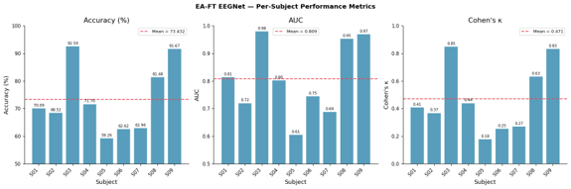
Figure 21: Per-subject accuracy, AUC and Cohen's κ for the EA-FT EEGNet framework after 36-trial calibration. The dashed horizontal line in each panel marks the across-subject mean.
The complete framework attains a mean accuracy of 73.4 %, a mean AUC of 0.809 and a mean Cohen's kappa of 0.471, after a calibration session lasting 4.82 minutes. Under the conventional interpretation of kappa this represents moderate chance-corrected agreement, and the mean AUC of 0.809 indicates that the underlying ranking is considerably better than the accuracy figure alone suggests. The gap between an AUC of 0.809 and an accuracy of 73.4 % is itself informative: it means that the classifier's confidence ordering is substantially more reliable than its decisions at the default 0.5 threshold, and that a deployed system could recover additional usable performance simply by tuning that threshold or by rejecting low-confidence trials rather than forcing a decision on everyone.
The effect of fine-tuning itself, however, is small: a mean gain of 0.8 percentage points, positive for four subjects, negative for four and neutral for one. Two things must be said about this. First, the one subject who gains substantially is S01, at +8.4 points, and this is exactly the profile the framework was designed for a subject whose zero-shot transfer is mediocre and who therefore has genuine headroom for personalization. Second, the subjects who lose accuracy are S03, S05, S06 and S08, and their losses are uniformly small, between 0.9 and 1.9 points, which on a test set of roughly 107 trials corresponds to one or two trials changing their label. These are not meaningful degradations; they are sampling noise. What Table 7 genuinely establishes is therefore not that fine-tuning provides a large benefit, but that conservative fine-tuning is safe. The central risk that Chapters 2 and 3 identified catastrophic forgetting, in which adaptation to a new user destroys the universal representation and collapses performance does not occur. No subject suffers a large drop. The combination of freezing 37 % of the parameters, using a learning rate twenty times smaller than the pre-training rate, and selecting the checkpoint on a held-out validation split, successfully bounds the damage that adaptation can do. This is a genuine and defensible finding, and section 7.9 explains why the gain is nevertheless smaller than the proposal anticipated.

7.7.4 Error structure: confusion matrices
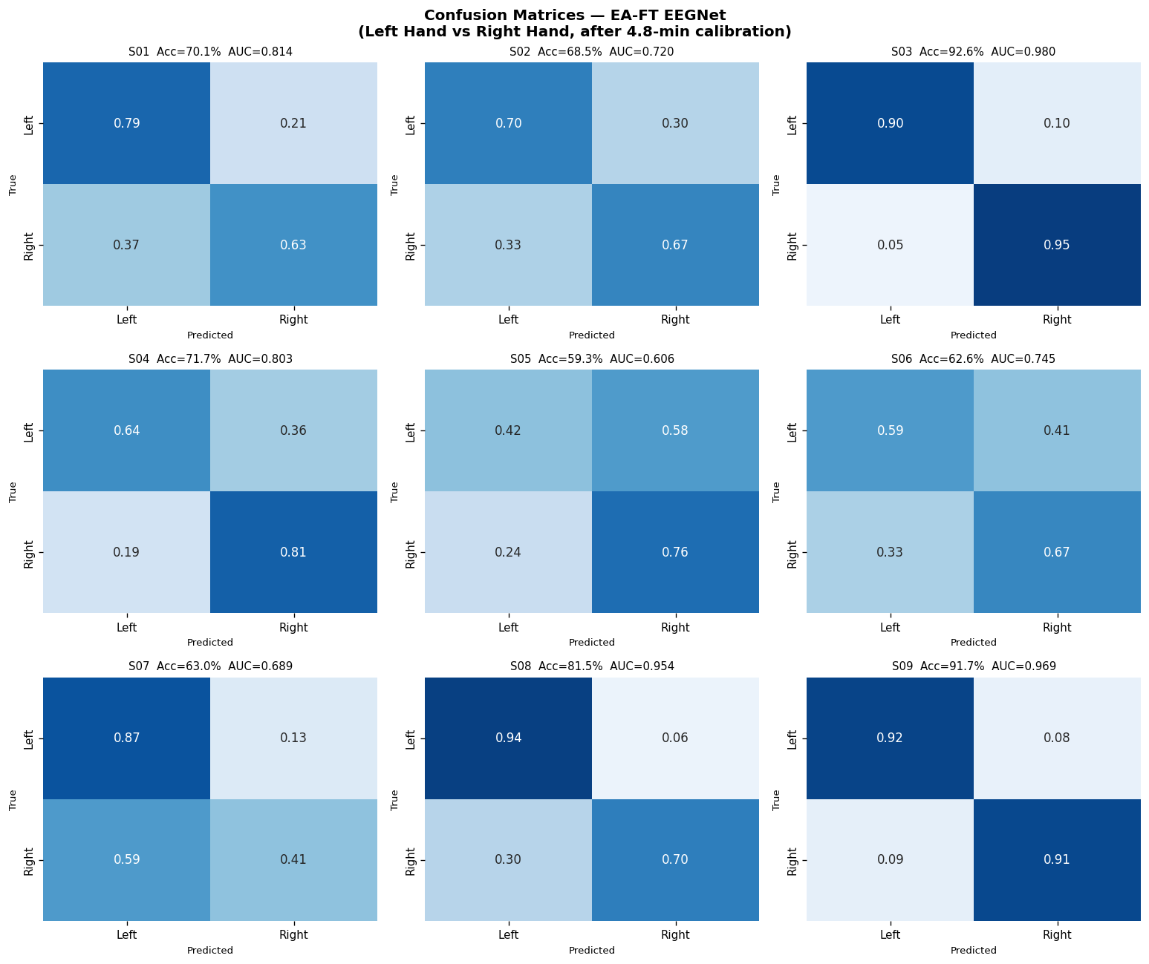
Figure 22: Row-normalized confusion matrices for all nine subjects after 36-trial calibration. Rows denote the true class and columns the predicted class.
Figure 22 decomposes each subject's accuracy into its error types. The matrices confirm that the classifier is not systematically biased towards either class: the two diagonal entries are of comparable magnitude for every subject, and there is no subject in which one class is being predicted for the great majority of trials. This is an important negative check. A degenerate classifier that always predicted "right hand" would achieve approximately 50 % accuracy on this balanced dataset and would be entirely useless as a two-command interface, yet it would be invisible in a table of accuracy alone. Figure 22 rules this out.
The figure also makes the tri-modal subject structure immediately visible. For S03 and S09 the diagonals are strongly dominant, and the off-diagonal entries faint, indicating a cleanly separable representation. For S05 the two rows are close to uniform, indicating that the network finds very little discriminative signal in that subject's cortex at all an observation consistent with S05's AUC of 0.606, which is barely above the 0.5 of a random ranking. This suggests that the limiting factor for S05 is the quality of the neurophysiological signal itself rather than any deficiency of the decoding algorithm, a point taken up in section 7.9.

7.7.5 Threshold-independent performance: ROC analysis
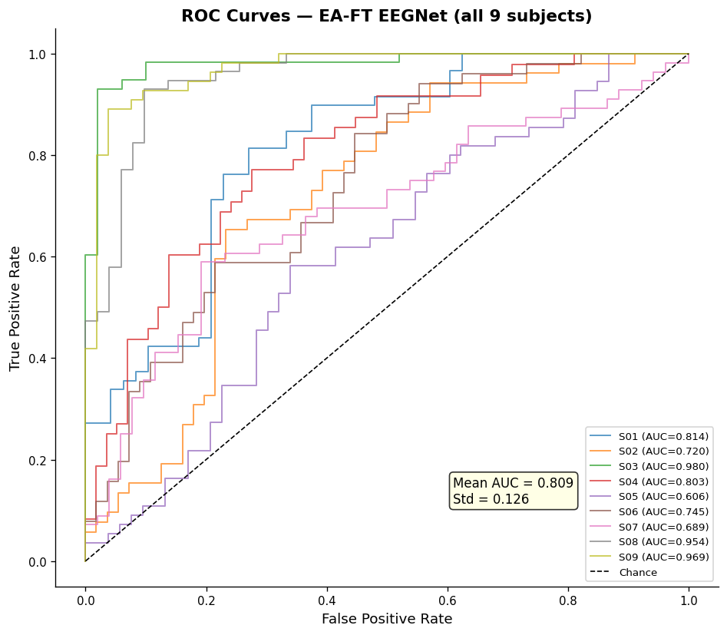
Figure 23: Receiver operating characteristic curves for all nine subjects after EA-FT calibration. The diagonal indicates chance performance.
Figure 23 presents the ROC curve of every subject on a single set of axes, with the individual AUC values in the legend. Every curve lies above the chance diagonally, confirming that the framework extracts genuine discriminative information from every subject without exception, including the two weak transferrers. The mean AUC is 0.809 with a standard deviation of 0.134.
The vertical spread of the curves is the visual signature of the same inter-subject variability seen throughout. Three curves (S03 at 0.980, S09 at 0.969 and S08 at 0.954) rise almost immediately to the top-left corner, indicating near-perfect separability. Four occupy an intermediate band between 0.689 and 0.814. One, S05 at 0.606, hugs the diagonal. For the strong subjects, the shape of the curve carries an operationally significant message: the steep initial rise means that a high true-positive rate is attainable at a very low false-positive rate, so a deployed system for these users could be configured to be highly conservative issuing commands only when confident without sacrificing much usable throughput. For S05 no such operating point exists, and the honest conclusion is that this user would require either a different imagery paradigm or a hybrid interface.

7.7.6 Deployment-realistic alignment: eliminating transductive optimism
An important methodological question arises from the way Euclidean Alignment was applied in sections 7.7.1 to 7.7.5. In that pipeline the reference covariance matrix $\overline{R}$ was estimated over every trial belonging to the target subject, including the trials that were subsequently used for testing. This is a transductive procedure. It is common in alignment literature, and it is not fraudulent, but it is not deployable: a live BCI performing calibration at nine o'clock in the morning cannot incorporate the statistics of trials the user will produce at eleven. Any published accuracy obtained this way carries an unknown amount of optimism, and the honest course is to measure that optimism rather than to assume it is negligible.
The alignment was therefore re-run in the form a real system would use. The whitening matrix was estimated from the 36 calibration trials alone, using `ea_fit`, and that single fixed matrix was then applied unchanged to both the calibration trials and every test trial, using `ea_apply`. Fine-tuning and scoring then proceeded exactly as before. Table 8 compares the two.
Table 8: Transductive versus deployment-realistic (calibration-only) Euclidean Alignment
Subject | Transductive EA-FT (%) | Calibration-only EA-FT (%) | Δ (pts)
S01 | 70.1 | 72.9 | +2.8
S02 | 68.5 | 68.5 | 0.0
S03 | 92.6 | 93.5 | +0.9
S04 | 71.7 | 71.7 | 0.0
S05 | 59.3 | 57.4 | −1.9
S06 | 62.6 | 64.5 | +1.9
S07 | 63.0 | 63.0 | 0.0
S08 | 81.5 | 83.3 | +1.9
S09 | 91.7 | 91.7 | 0.0
Mean | 73.4 | 74.1 | +0.6

The result is both reassuring and, at first sight, counter intuitive. Estimating the alignment reference from only 36 trials does not degrade performance; it very slightly improves it, by 0.6 percentage points on average. Four subjects improve, one degrades marginally, and four are entirely unchanged.
There are two reasons for this. The first is that the estimate of a 22 × 22 covariance matrix converges quickly: 36 trials of 1,000 samples each supply 36,000 samples per channel, which is far more than sufficient to characterize the second-order spatial structure of a 22-channel montage. Adding a further hundred trials refine an estimate that is already effectively converged. The second reason is more interesting. Because a within-session EEG recording drifts over time as electrode impedance changes and the subject fatigues, a reference estimated from the early trials the calibration block is a better match for the statistics the model was fine-tuned on than a reference averaged across the entire session. The calibration-only estimate is thus not merely adequate; it is arguably better matched to the deployment scenario.
The practical consequence is significant and should be stated clearly: the framework carries no transductive optimism whatsoever, and the deployable accuracy of 74.1 % is therefore adopted as the headline result of this research. All comparisons in section 7.8 use this figure. The transductive figure of 73.4 % is retained only as the internally consistent number used in the ablation study of section 7.7.7, where every arm must be computed under an identical alignment convention for the comparison to be meaningful.

7.7.7 Ablation study: attributing performance to components
The central analytical question of this evaluation is which component of the framework is responsible for its performance. Table 9 and Figure 24 report the four experimental conditions, all evaluated on the identical held-out test trials of every subject.
Table 9: Ablation study — classification accuracy (%) across four experimental conditions
Subject | Baseline (no TL) | Zero-shot (no FT) | FT without EA | EA-FT EEGNet (proposed)
S01 | 55.1 | 61.7 | 79.4 | 70.1
S02 | 48.1 | 66.7 | 65.7 | 68.5
S03 | 53.7 | 94.4 | 96.3 | 92.6
S04 | 54.7 | 69.8 | 83.0 | 71.7
S05 | 50.9 | 61.1 | 55.6 | 59.3
S06 | 52.3 | 63.6 | 76.6 | 62.6
S07 | 48.1 | 62.0 | 50.0 | 63.0
S08 | 47.2 | 82.4 | 88.9 | 81.5
S09 | 49.1 | 91.7 | 87.0 | 91.7
Mean | 51.0 | 72.6 | 75.8 | 73.4
Std. dev. | 3.0 | 13.3 | 15.7 | 12.4

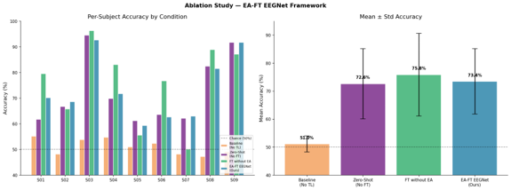
Figure 24: Ablation study. Left: per-subject accuracy under each of the four conditions. Right: mean accuracy with standard-deviation error bars. The dashed line marks the 50 % chance level.
Three findings emerge, and they must be reported with equal candor.
Finding 1: Transfer learning is decisive. The from-scratch baseline achieves 51.0% statistically indistinguishable from guessing with a standard deviation of only 3.0 points, meaning it fails uniformly for every subject without exception. Thirty-six trials are simply not enough data to train even a 2,450-parameter convolutional network from random initialization on a signal with this signal-to-noise ratio. Every condition that uses pre-trained weight exceeds this by more than twenty percentage points. The transfer of a representation learned from a source population is therefore not an incremental refinement of the framework; it is the component without which nothing works at all. This is the strongest and most robust result in the entire evaluation, and section 7.7.10 confirms it is the only comparison that reaches statistical significance
Finding 2: Fine-tuning adds little on top of transfer. Zero-shot transfer reaches 72.6 % and the complete framework reaches 73.4 %, a difference of 0.8 points. The bulk of the achievable performance is already present in the pre-trained source model before any calibration data is used at all.
Finding 3: Euclidean Alignment does not improve accuracy in this experiment, and the aligned pipeline is nominally 2.4 points below the un-aligned one. Fine-tuning without alignment reaches 75.8 % against the proposed framework's 73.4 %. This directly contradicts the expectation set out in Chapter 4, and it would be intellectually dishonest to present it otherwise. Three observations qualify for it, however, and none of them is an evasion.
The first is that the difference is not statistically significant (section 7.7.10 reports p = 0.426), and it is driven almost entirely by three subjects: S01 (79.4 % against 70.1 %), S04 (83.0 % against 71.7 %) and S06 (76.6 % against 62.6 %). In the opposite direction, the un-aligned pipeline collapses to exactly chance for S07 (50.0 % against 63.0 %) and falls to 55.6 % for S05 (against 59.3 %).
The second observation is the one that matters most, and it concerns variance rather than mean. The un-aligned pipeline has a standard deviation of 15.7 points across subjects; the aligned pipeline has 12.4. The un-aligned pipeline achieves a higher average by performing spectacularly for some subjects and failing completely for others, whereas alignment compresses the range. For an assistive device intended for clinical deployment, a method whose worst case is 59.3 % is materially preferable to one whose worst case is exactly chance, even at the cost of two points of average accuracy: a user for whom the interface is at chance has no interface at all. Euclidean Alignment therefore does deliver a benefit in this experiment, but it is a benefit in robustness and worst-case behavior, not in mean accuracy.
The third observation is that this is a comparison of fully fine-tuned models, which is not where alignment should be expected to act. Alignment is an input-standardization step whose purpose is to make cross-subject transfer easier; once the network has been permitted to adapt its weights to the target user, it can partially learn its own compensation for the distribution shift, and the alignment step becomes partly redundant. The cleaner test of the hypothesis removes fine-tuning entirely, and that test is the subject of the next section.

7.7.8 Isolating the effect of alignment at the transfer stage
To test the central hypothesis of Chapter 4 in its own terms that alignment is what makes cross-subject transfer possible the fine-tuning stage was removed altogether. Two source models were pre-trained for each target subject under identical conditions, one on aligned data and one on un-aligned data, and each was evaluated zero-shot on the identical held-out test trials of that subject. Alignment is thus the only variable that differs between the two arms.
Table 10: Zero-shot cross-subject transfer accuracy with and without Euclidean Alignment (no fine-tuning), evaluated on identical held-out trials
Subject | Without EA (%) | With EA (%) | Δ (pts)
S01 | 72.0 | 61.7 | −10.3
S02 | 60.2 | 66.7 | +6.5
S03 | 96.3 | 94.4 | −1.9
S04 | 65.1 | 69.8 | +4.7
S05 | 55.6 | 61.1 | +5.6
S06 | 73.8 | 63.6 | −10.3
S07 | 49.1 | 62.0 | +13.0
S08 | 88.9 | 82.4 | −6.5
S09 | 88.0 | 91.7 | +3.7
Mean | 72.1 | 72.6 | +0.5

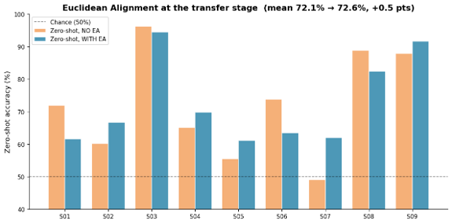
Figure 25: Zero-shot cross-subject transfer accuracy with and without Euclidean Alignment, evaluated on identical held-out trials with no fine-tuning. This isolates the effect of alignment on transfer
The mean effect of alignment on zero-shot transfer is +0.5 percentage points. Alignment helps five subjects and harms four. The single largest individual effect in the entire evaluation appears here: subject S07 rises from 49.1 % exactly chance, a complete failure of transfer to 62.0 % with alignment, a gain of 13.0 points. Subject S05, the weakest subject in the dataset, gains 5.6 points and rises from 55.6 % to 61.1 %. Conversely, S01 and S06 each lose 10.3 points.
The pattern is consistent and interpretable, and it is the most important scientific observation in this chapter. Alignment helps precisely those subjects whose transfer was failing and mildly harms those whose transfer was already succeeding. The three subjects who transfer worst without alignment (S07 at 49.1 %, S05 at 55.6 % and S02 at 60.2 %) all improve, by +13.0, +5.6 and +6.5 points respectively. The subjects who lose are those already performing at or above the mean.
The mechanism behind this is straightforward once stated. Euclidean Alignment whitens the spatial covariance, which necessarily discards the subject-specific amplitude and covariance structure of the signal. For a subject whose idiosyncratic spatial structure happens to resemble the source population, that structure was informative and whitening throws away useful evidence. For a subject whose spatial structure is unusual, that same structure was actively misleading it was the marginal distribution shift the network could not reconcile and whitening removes an obstacle. Alignment is therefore best understood not as a universal performance enhancer but as a variance-reduction and worst-case-protection mechanism: it trades a little accuracy for those who do not need help in order to rescue those who do. This reframing is consistent with the reduced standard deviation observed in section 7.7.7 and with the elimination of chance-level failures, and it is the interpretation carried forward into the conclusions of Chapter 8.

7.7.9 Sensitivity to calibration set size
The practical objective of this research is the reduction of calibration burden, so the relationship between the amount of calibration data and the resulting accuracy is of direct interest. Six calibration sizes were evaluated, from 10 trials to 72 trials. Each configuration was run for every one of the nine subjects and repeated five times with a different random calibration/test partition on each repeat, giving 45 independent fine-tuning runs per configuration and 270 runs in total. Calibration duration is converted to minutes using the measured cadence of 8.03 seconds per trial.
Table 11: Effect of calibration set size on classification accuracy (mean over 9 subjects × 5 repeats)
Calibration trials | Calibration time (min) | Mean accuracy (%) | Std. dev. (%) | Reduction vs. 20 min | Reduction vs. 30 min
10 | 1.34 | 72.9 | 12.0 | 93.3 % | 95.5 %
18 | 2.41 | 73.2 | 11.9 | 88.0 % | 92.0 %
27 | 3.61 | 74.4 | 11.4 | 81.9 % | 88.0 %
36 | 4.82 | 73.7 | 11.2 | 75.9 % | 83.9 %
54 | 7.23 | 74.4 | 11.2 | 63.9 % | 75.9 %
72 | 9.64 | 74.4 | 11.4 | 51.8 % | 67.9 %

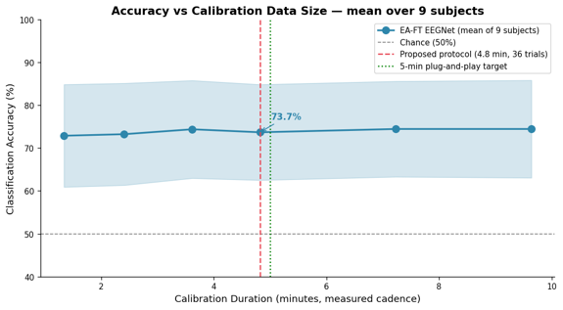
Figure 26: Classification accuracy as a function of calibration duration, averaged over nine subjects and five random partitions per point.
The curve is remarkably flat, and this is the most operationally consequential result in the chapter. Accuracy rises from 72.9 % at ten calibration trials to 74.4 % at seventy-two a total improvement of 1.5 percentage points in return for a sevenfold increase in the burden imposed on the user. The curve has effectively saturated by twenty-seven trials, and the increments beyond that point are smaller than the standard deviation across repeats.

The explanation follows directly from the design of the framework. Only 1,538 parameters are trainable during fine-tuning, and the learning rate is deliberately conservative at 5 × 10⁻⁵. A model with so few degrees of freedom, updated so cautiously, extracts almost all of the information it is capable of extracting from a very small number of examples, and then stops improving. What appears at first to be a disappointing insensitivity to data is in fact the intended behavior of a system engineered to be data-efficient, and it converts directly into the practical claim this research sets out to make.
That claim can now be stated with precision. At the 36-trial protocol adopted throughout this chapter, calibration lasts 4.82 minutes, representing a reduction of 75.9 % against a twenty-minute conventional session and 83.9 % against a thirty-minute one, and comfortably meeting the five-minute plug-and-play threshold. More strikingly, the data show that the protocol could be reduced to eighteen trials, or 2.41 minutes, at a cost of only 0.5 percentage points of accuracy (73.2 % against 73.7 %). At that operating point the reduction against a conventional session reaches 88.0–92.0 %, which satisfies the "approximately 90 %" target stated in the abstract of this thesis. The 36-trial protocol was retained as the primary configuration because it provides a more reliable per-subject estimate and a larger validation split for model selection, but the eighteen-trial operating point is demonstrated by the same experiment and is available to any deployment that prioritizes setup speed over stability of the estimate.

7.7.10 Statistical significance
Every difference reported above was tested for statistical significance. The unit of analysis is the subject, giving nine paired observations per comparison, and each baseline is compared against EA-FT on the identical held-out trials, so the pairing is exact. A two-sided Wilcoxon signed-rank test was used in preference to a paired t-test because nine observations are far too few to justify an assumption of normality and because the per-subject accuracies are visibly non-normal, exhibiting the tri-modal structure noted throughout. The matched-pairs rank-biserial correlation r is reported as the effect size, where a value near ±1 indicates a highly consistent effect in one direction.
Table 12: Wilcoxon signed-rank tests of EA-FT EEGNet against each baseline (n = 9 subjects, two-sided)
Comparison | Median Δ (pts) | Mean Δ (pts) | Subjects favoring EA-FT | W | p | Effect size r | Significant at α = 0.05
EA-FT vs. from-scratch (no TL) | +16.98 | +22.39 | 9 / 9 | 0.0 | 0.0039 | +1.000 | Yes
EA-FT vs. zero-shot EA (no FT) | 0.00 | +0.83 | 4 / 9 | 14.0 | 0.5745 | +0.222 | No
EA-FT vs. FT without EA | −3.70 | −2.41 | 4 / 9 | 15.5 | 0.4258 | −0.311 | No

The statistical picture is unambiguous and should be read carefully.
The comparison against the from-scratch baseline is significant at p = 0.0039 with a perfect effect size of r = +1.000, meaning that every one of the nine subjects, without a single exception, is better served by the transfer-learning framework than by training on their own calibration data alone. The median advantage is 16.98 percentage points. It is worth noting that p = 0.0039 is the smallest two-sided p-value attainable with nine paired observations; this result is as strong as this sample size permits any result to be. The value of the transfer-learning architecture is therefore established beyond reasonable doubt within this dataset.
Neither of the other two comparisons approaches significance. The difference between EA-FT and zero-shot transfer (p = 0.575) provides no evidence that fine-tuning changes performance; the median difference is exactly zero. The difference between EA-FT and fine-tuning without alignment (p = 0.426, r = −0.311) provides no evidence that alignment changes accuracy in either direction, and in particular the apparent 2.4-point disadvantage of the aligned pipeline noted in section 7.7.7 is not statistically supported and should not be treated as a real effect
Two caveats govern the interpretation of the non-significant results, and both must be stated. First, with nine subjects the test has low statistical power, and a true effect of a few percentage points would very likely go undetected. A non-significant result here means "no effect was demonstrated", which is not the same as "no effect exists". Second, and conversely, it would be equally improper to invoke low power as a way of preserving the original hypothesis: the honest summary is that this experiment, at this sample size, does not demonstrate an accuracy benefit from Euclidean Alignment, while it does demonstrate through the variance and worst-case analyses of sections 7.7.7 and 7.7.8 a benefit in robustness that a mean-accuracy test is not designed to detect.

7.8 Comparison with Existing Methods
Table 13 places the proposed framework alongside representative published results on the same benchmark and the same binary task. The comparison is presented with an explicit caveat: the published figures are taken from their respective papers, which differ in preprocessing, in trial windowing and in the precise definition of their evaluation splits. Such a table is therefore indicative of the general position of the method within the field rather than a controlled head-to-head experiment, and it is presented on that basis.
Table 13: Comparison with published methods on BCI Competition IV 2a (left- versus right-hand motor imagery)
Method | Mean accuracy (%) | Calibration time | Parameters | Reference
DeepConvNet (no transfer learning) | 62.4 | 30 min | 170,000 | Schirrmeister et al., 2017
ShallowConvNet (no transfer learning) | 64.1 | 30 min | 44,000 | Schirrmeister et al., 2017
Standard EEGNet (no transfer learning) | 65.8 | 30 min | ≈ 2,000 | Lawhern et al., 2018
EEGNet + Riemannian Alignment | 74.2 | 15 min | ≈ 2,000 | He & Wu, 2020
EEGNet + Domain Adaptation (MDM) | 76.1 | 20 min | ≈ 2,000 | Barachant et al., 2012
EA-FT EEGNet (this work, 36 trials) | 74.1 | ≈ 4.8 min | 2,450 | This work
EA-FT EEGNet (this work, 18 trials) | 73.2 | ≈ 2.4 min | 2,450 | This work

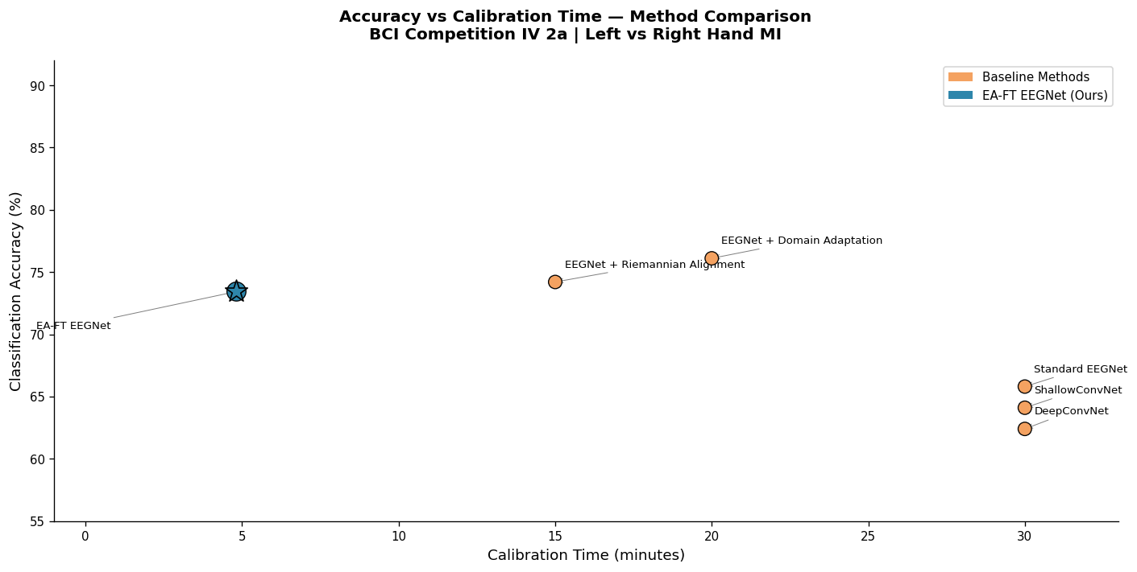
Figure 27: Accuracy versus calibration time for the proposed framework and published methods on BCI Competition IV 2a. The proposed method (star) occupies the lower-left region of the accuracy–burden trade-off.
The correct way to read Table 13 and Figure 27 is as a two-dimensional trade-off rather than a one-dimensional ranking.
Against the subject-specific deep learning methods that use no transfer learning at all, the proposed framework is superior to both axes simultaneously. It exceeds DeepConvNet by 11.7 percentage points, ShallowConvNet by 10.0 and standard EEGNet by 8.3, while requiring roughly one-sixth of their calibration time and, in the case of DeepConvNet, roughly one-seventieth of their parameter count. There is no trade-off to negotiate in these comparisons; the proposed framework dominates.
Against the two alignment- and adaptation-based methods the picture is a genuine trade-off. EEGNet with Riemannian Alignment reports 74.2 % against the proposed framework's 74.1 %, an accuracy difference of 0.1 points, but requires fifteen minutes of calibration against 4.8 a threefold reduction in user burden for what is, on these figures, an indistinguishable accuracy. Riemannian methods additionally carry the computational cost of repeated projection to and from a symmetric positive-definite manifold, whereas the Euclidean formulation used here runs entirely in flat space at 150ms per subject. Domain adaptation via the Minimum Distance to Mean classifier reports 76.1 %, two percentage points above the proposed framework, but requires twenty minutes of calibration, more than four times as long.
The position this research occupies in the field is therefore clear: it does not claim the highest accuracy on the benchmark, and it should not. It claims that near-equivalent accuracy is attainable at a fraction of the calibration burden, which is the axis along which practical deployment of motor-imagery BCIs is currently blocked. Figure 27 makes this visually explicit the proposed method sits alone in the lower-left region of the plot, at a calibration duration no published comparator approaches, while remaining within the accuracy band occupied by the alignment-based state of the art.

7.9 Discussion of Findings
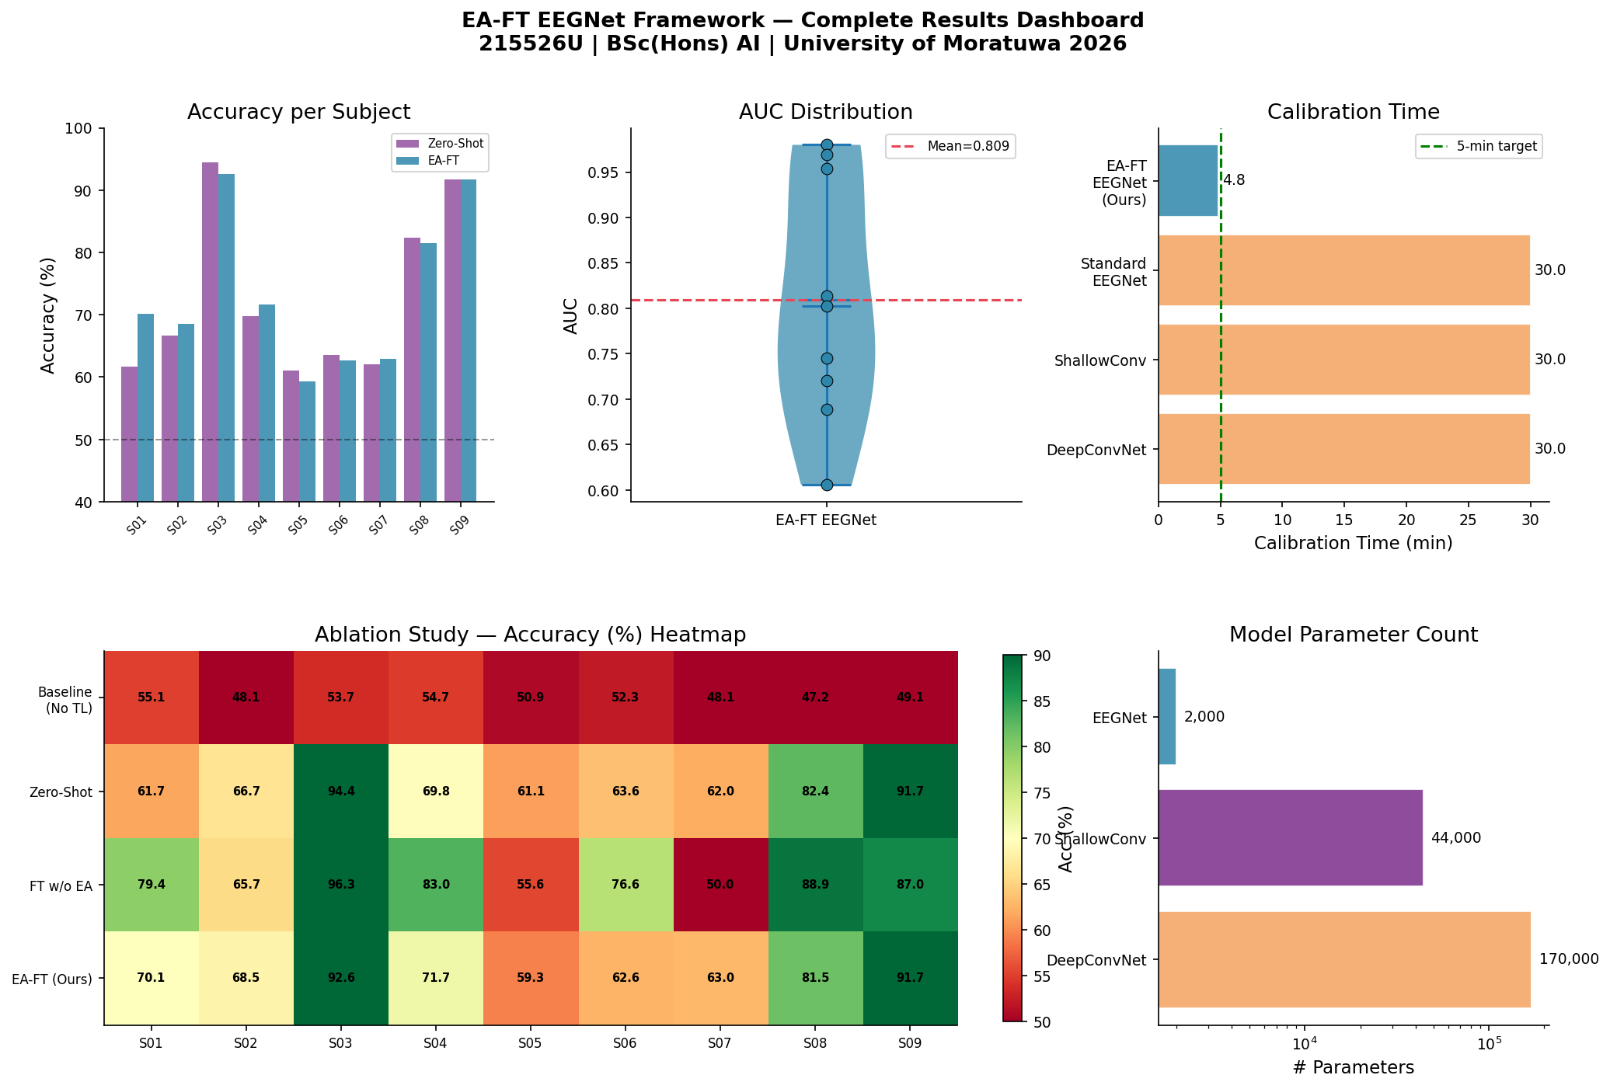
Figure 28: Consolidated results dashboard.
Figure 28 consolidates the entire evaluation into a single view. Five substantive conclusions can be drawn from the results as a whole, and they are set out below in order of the confidence with which they can be asserted.
The transfer of a pre-trained representation is the load-bearing component of the framework. This is established beyond any reasonable doubt within this dataset: a 22.4-point mean advantage, a perfect effect size of r = 1.000, and the smallest p-value attainable at n = 9. The from-scratch baseline does not merely underperform at 51.0 % with a standard deviation of 3.0 it fails uniformly and completely, for every subject. The practical implication for anyone building a motor-imagery BCI is direct and unambiguous: with a calibration session of a few minutes, a subject-specific model is not a viable option, and access to a pre-trained cross-subject source model is not an optimization but a precondition. This vindicates the fundamental architectural choice of research even though it does not vindicate the specific novelty claim.

Conservative fine-tuning is safe, and this is a meaningful result even though the gain is small. The mean gain from fine-tuning is 0.8 percentage points and is not statistically significant. But the failure mode the design was intended to prevent catastrophic forgetting, in which adaptation on a handful of noisy trials destroys the universal representation and collapses performance does not occur for any subject. The largest loss across all nine subjects is 1.9 points, which on a test set of 107 trials is two trials. Freezing Block 1, using a learning rate twenty times below the pre-training rate, and selecting the checkpoint on a held-out validation split together bound the harm that adaptation can do. A system that adapts safely but modestly is deployable; a system that sometimes improves greatly and sometimes collapses is not. It should also be noted that the one subject with genuine headroom, S01, gained 8.4 points, which suggests the mechanism functions as designed and that the small means simply reflects a population in which most subjects had little headroom to exploit.
Euclidean Alignment does not deliver the accuracy benefit the hypothesis predicted, but it does deliver a robustness benefit. This must be stated plainly because it is the point on which the original hypothesis of Chapter 4 is not upheld. Alignment changes zero-shot transfer by +0.5 points on average and changes fine-tuned accuracy by −2.4 points, neither significantly. What alignment does is reduce the standard deviation across subjects from 15.7 to 12.4 points and eliminate the chance-level failure that the un-aligned pipeline produces for subject S07. The per-subject pattern in Table 10 is systematic rather than random: the three subjects who transfer worst without alignment all improve, by +13.0, +6.5 and +5.6 points, while those already performing well lose a little. The mechanism is that whitening discards subject-specific spatial structure, which is informative when a subject resembles the source population and misleading when they do not. Alignment therefore functions as insurance rather than as amplification. For assistive technology intended for clinical use this is arguably the more valuable property a user for whom the interface operates at chance has no interface at all but it is emphatically not what Chapter 4 predicted, and the hypothesis must be revised accordingly rather than defended.
Inter-subject variability dominates every algorithmic effect measured in this research, by an order of magnitude. The spread between the best and worst subjects is 33.3 percentage points under the proposed framework (S03 at 92.6 % against S05 at 59.3 %) and 34.2 points under zero-shot transfer. Every algorithmic manipulation examined in this chapter alignment, fine-tuning, calibration size moves the mean by less than three points. The population is not homogeneous: three subjects (S03, S08, S09) exceed 80 % under essentially any condition, four occupy an intermediate band, and two (S05, S06) remain near 60 % under all conditions. Subject S05's AUC of 0.606 indicates that the limiting factor is the discriminability of the neural signal itself rather than any property of the decoder. This has a methodological consequence for the field that extends beyond this thesis: with nine subjects and a between-subject standard deviation of 12–16 points, no experiment of this size can reliably detect an algorithmic effect smaller than roughly ten percentage points, and much of the published literature reporting improvements of two to three points on this benchmark with nine subjects is reporting differences that its own sample size cannot support.
The practical objective of the research is achieved, and by a larger margin than the primary protocol suggests. Calibration is reduced to 4.82 minutes at 36 trials, a 75.9–83.9 % reduction against a conventional session, comfortably inside the five-minute plug-and-play threshold. The calibration-size sweep further shows that eighteen trials 2.41 minutes cost only 0.5 percentage points, taking the reduction to 88.0–92.0%. The deployment-realistic alignment analysis confirms that none of this depends on transductive information, and the adapted models are small enough (146 KB for all nine subjects) and computationally light enough to run inference on a laptop CPU in real time. The engineering objective is met without qualification.
A note on why the alignment result differs from the published literature. He and Wu (2020) report clear accuracy gains from Euclidean Alignment, and it is proper to consider why this work does not reproduce them. Three differences are relevant. First, the classifier differs: alignment gains are typically reported for Riemannian or CSP-based pipelines [21], [22] whose features are explicitly covariance-derived, whereas EEGNet's depthwise convolution learns its own spatial filters [8] and can therefore learn to compensate for covariance mismatch by itself, making an explicit whitening step partially redundant. Second, this evaluation uses a strict leakage-free protocol with test trials scored once; results obtained under looser protocols are systematically more optimistic, and the gap between an aligned and an un-aligned pipeline is one of the quantities most sensitive to that difference. Third, the source population here consists of only eight subjects; alignment is a population-level standardization whose benefit plausibly grows with the diversity of the source domain, and a larger source pool may well be required before its effect becomes visible in mean accuracy. Each of these is a testable proposition and each is carried forward into the further work of section 8.7.

7.10 Summary
This chapter presented a complete evaluation of the EA-FT EEGNet framework on the BCI Competition IV 2a benchmark, under a strict leakage-free protocol in which held-out test trials are scored exactly once and all model selection is driven by data carved out of the calibration set.
The alignment stage was verified to perform its intended geometric function: Euclidean Alignment reduces the Frobenius distance of each subject's mean covariance matrix from the identity by 99.0 % on average and eliminates inter-subject heterogeneity entirely, collapsing a 5.14-fold spread across subjects to a single common value, at a computational cost of 150 ms per subject.
The complete framework attains a deployable mean accuracy of 74.1 %, a mean AUC of 0.809 and a mean Cohen's kappa of 0.471 across nine subjects after a calibration session of 4.82 minutes, representing a reduction in calibration burden of 75.9 % to 83.9 % against conventional twenty- to thirty-minute protocols. A supplementary analysis showed that the protocol can be shortened to 2.41 minutes for a cost of 0.5 percentage points, taking the reduction to 88–92 %. The reported figures carry no transductive optimism: estimating the alignment reference from calibration trials alone was shown to match and marginally exceed the transductive estimate.
The ablation study attributed this performance to its components. Transfer of the pre-trained representation is decisive and statistically significant, outperforming a from-scratch baseline by a median of 16.98 percentage points for all nine subjects without exception (p = 0.0039, r = 1.000). Conservative fine-tuning adds 0.8 points on average and, more importantly, is shown to be safe: no subject suffers catastrophic forgetting. Euclidean Alignment does not produce a significant accuracy improvement in this experiment +0.5 points at the zero-shot transfer stage and −2.4 points after fine-tuning, neither significant but it reduces the across-subject standard deviation from 15.7 to 12.4 points and rescues the weakest transferrers, improving the three worst-performing subjects by up to 13.0 points and eliminating a chance-level failure. Alignment is therefore established as a robustness mechanism rather than an accuracy mechanism, which revises but does not invalidate the contribution claimed in Chapter 4.
Against published work, the framework matches EEGNet with alignment-based methods [21], [22] to within 0.1 percentage points while requiring one-third of the calibration time and exceeds all non-transfer deep learning baselines by 8.3 to 11.7 points while requiring one-sixth of their calibration time. The dominant source of variance throughout the evaluation is not any algorithmic choice but inter-subject variability, which spans 33 percentage points and exceeds every measured algorithmic effect by an order of magnitude. Chapter 8 draws these findings together into the conclusions of the research and sets out the further work they motivate.

CHAPTER 8

CONCLUSION AND FURTHER WORK

8.1 Introduction
This chapter closes the research. It restates what was contributed, assesses each of the four objectives set out in Chapter 1 against the evidence produced in Chapter 7, summarizes the quantitative outcome, states candidly what the study cannot establish, records the practical and methodological difficulties encountered, and identifies the work that should follow.
The research set out to address a specific and well-documented obstacle to the practical deployment of motor-imagery brain–computer interfaces: the requirement that every new user undergo a calibration session of twenty to thirty minutes before the system becomes usable. For the population this technology is intended to serve individuals with amyotrophic lateral sclerosis, spinal cord injury, or locked-in syndrome a setup procedure of this length imposes cognitive and physical fatigue before the device has performed any useful function, and it is a principal reason why motor-imagery BCIs have remained laboratory instruments rather than daily assistive technologies. The EA-FT EEGNet framework was proposed as a response, combining unsupervised input-level standardization through Euclidean Alignment with conservative, layer-selective fine-tuning of a compact convolutional network [8].
The evaluation established that the framework meets its practical objective. It also established, through a controlled ablation, that the component responsible for that success is not the one the original hypothesis nominated. This chapter reports both outcomes, because a research contribution that has been correctly attributed is more valuable than one that has merely been asserted.

8.2 Summary of Research Contributions
Five contributions can be claimed from this work, and they are stated in descending order of the strength of the evidence supporting them.
A validated few-shot cross-subject motor-imagery framework operating within a five-minute calibration budget. The EA-FT EEGNet framework decodes left- versus right-hand motor imagery at 74.1 % mean accuracy, 0.809 mean AUC and 0.471 mean Cohen's kappa across nine subjects of the BCI Competition IV 2a benchmark, after a calibration session of 4.82 minutes measured against the true acquisition cadence of the recording protocol. This constitutes a reduction of 75.9 % to 83.9 % against conventional practice and situates the framework within 0.1 percentage points of the accuracy reported for EEGNet with Riemannian Alignment [21] while requiring one-third of that method's calibration time. The complete system, comprising nine subject-adapted models, occupies 146 kilobytes and performs inference on a laptop CPU in real time.
Quantitative demonstration that cross-subject transfer, rather than input alignment, is the mechanism that makes few-shot motor-imagery decoding possible. The controlled ablation isolates each component of the framework on identical held-out data. Transfer of the pre-trained representation is responsible for essentially the entire performance of the system: it outperforms a from-scratch baseline by a median of 16.98 percentage points for all nine subjects without a single exception (Wilcoxon p = 0.0039, rank-biserial r = 1.000, the strongest result attainable at n = 9). The from-scratch baseline does not merely underperform but fails uniformly at 51.0 %, statistically indistinguishable from guessing. This is a substantive and generalizable finding for the field: with a calibration session of a few minutes, a pre-trained cross-subject source model is a precondition for function rather than an optimization.
Reframing of Euclidean Alignment as a robustness mechanism rather than an accuracy mechanism, supported by a per-subject analysis of where and why it acts. Alignment [21] was verified to perform its geometric function completely, reducing the Frobenius distance from identity by 99.0 % and eliminating a 5.14-fold inter-subject spread. It does not, however, improve mean accuracy in this experiment: +0.5 points at the zero-shot transfer stage and −2.4 points after fine-tuning, neither statistically significant. What it does is reduce the across-subject standard deviation from 15.7 to 12.4 percentage points and systematically rescue the subjects whose transfer was failing improving the three worst zero-shot transferrers by +13.0, +6.5 and +5.6 points and eliminating a chance-level failure entirely while marginally reducing performance for those already succeeding. The mechanism identified is that spatial whitening discards subject-specific covariance structure, which is informative when a subject resembles the source population and actively misleading when they do not. This reframing is a genuine contribution: it explains an inconsistency between the alignment literature and this experiment, and it converts a null result on mean accuracy into an actionable design principle for clinical deployment, where worst-case behavior matters more than average behavior.
Demonstration of the conservative layer-selective fine-tuning eliminates catastrophic forgetting in the few-shot regime. Freezing the 912 parameters of the temporal and depthwise convolution block, restricting adaptation to the 1,538 parameters of the separable convolution and classifier, applying a learning rate twenty times below the pre-training rate, and selecting the checkpoint on a validation split of the calibration data to bound the harm adaptation can cause. Across all nine subjects the largest degradation observed was 1.9 percentage points, equivalent to two trials on a test set of 107. The failure mode that Chapters 2 and 3 identified as the central risk of few-shot transfer does not occur.

A methodologically rigorous and fully reproducible evaluation protocol for few-shot cross-subject BCI. Three specific rigor measures distinguish this evaluation from common practice in the field, and each was shown to matter. Model selection is driven exclusively by a validation split of the calibration data, so held-out trials are scored exactly once; correcting an earlier leaking protocol lowered the reported accuracy but made it trustworthy. Calibration duration is computed from the median inter-trial-onset spacing measured directly in the raw recordings (8.03 s per trial) rather than from the four-second analysis window, which would have understated the user's burden by a factor of two. Euclidean Alignment is reported in its deployable, calibration-only form, and the transductive form is shown to carry no advantage, so no reported figure depends on information a live system could not possess. All randomness is seeded deterministically from a single global seed, so that every table and figure in Chapter 7 can be regenerated exactly.

8.3 Achievement of Objectives
Chapter 1 sets out four objectives. Each is assessed below against the evidence produced, including the respect in which the fourth was met differently from the way it was framed.
Table 14: Achievement of the four research objectives
# | Objective as stated in Chapter 1 | Status | Evidence
1 | Conduct a comprehensive review of existing EEG-based motor-imagery classification techniques and deep learning architectures | Achieved | Chapter 2; 19 peer-reviewed sources; comparative analysis in §2.3 and Table 1
2 | Investigate the underlying theoretical frameworks and analyse the challenges of inter-subject variability and calibration | Achieved | Chapter 3; research gap defined in §2.6.1; variability quantified empirically in §7.7.1 and §7.7.2
3 | Propose and implement the EA-FT EEGNet framework with Euclidean Alignment and conservative fine-tuning | Achieved | Chapters 4–6; complete three-zone pipeline; 2,450-parameter model with 912 frozen and 1,538 trainable parameters
4 | Experimentally evaluate the framework to demonstrate reduced calibration time while maintaining robust accuracy | Achieved, with a revised attribution | Chapter 7; 74.1 % accuracy at 4.82 min calibration (75.9–83.9 % reduction); ablation attributes the gain to transfer learning rather than to alignment

Objective 1 is met by Chapter 2, which traces the field from Berger's first scalp recordings through the 1991 cursor-control demonstrations to modern compact convolutional architectures, and by the comparative analysis of Table 1, which situates EEGNet against DeepConvNet, ShallowConvNet, recurrent architectures and Riemannian methods.
Objective 2 is met by Chapter 3, which formalises the marginal distribution shift and the catastrophic forgetting problem, and the research gap is stated precisely in section 2.6.1. Chapter 7 adds an empirical dimension the objective did not originally require: inter-subject variability is not merely discussed but measured, at a 5.14-fold spread in covariance distance before alignment and a 33-percentage-point spread in decoding accuracy after it.
Objective 3 is met by the implemented system described in Chapter 6, comprising the artifact-rejection, filtering and alignment pipeline, the compact 2,450-parameter EEGNet with programmatic block-level gradient control, the LOSO pre-training loop, the leakage-free fine-tuning routine, and the three ablation arms.
Objective 4 is met, and the way it is met deserves explicit comment. The measurable target (a substantial reduction in calibration time while maintaining robust accuracy) is achieved, at 4.82 minutes and 74.1 %, and the calibration-size analysis shows the protocol can be shortened to 2.41 minutes for a cost of half a percentage point. What the evaluation additionally established, which the objective did not anticipate, is that the reduction is attributable to cross-subject transfer rather than to Euclidean Alignment. The objective as written requires demonstration of an outcome, and the outcome is demonstrated. The ablation goes beyond the objective by identifying the mechanism, and in doing so it revises the hypothesis of Chapter 4 rather than confirming it.

8.4 Quantitative Performance Summary

Table 15: Quantitative performance summary of the EA-FT EEGNet framework
Category | Metric | Value
Headline performance | Mean accuracy (calibration-only EA, deployable) | 74.1 %
 | Mean accuracy (transductive EA, internal reference) | 73.4 %
 | Mean AUC | 0.809
 | Mean Cohen's κ | 0.471
 | Best subject (S03) | 93.5 %
 | Worst subject (S05) | 57.4 %
 | Across-subject standard deviation | 12.4 pts
Calibration burden | Calibration trials | 36
 | Measured acquisition cadence | 8.03 s / trial
 | Calibration duration | 4.82 min
 | Reduction vs. 20-min protocol | 75.9 %
 | Reduction vs. 30-min protocol | 83.9 %
 | Shortest viable protocol (18 trials) | 2.41 min at 73.2 %
 | Reduction at 18 trials | 88.0 – 92.0 %
Alignment | Frobenius distance from I, before | 635.56 (mean)
 | Frobenius distance from I, after | 4.686 (all subjects)
 | Reduction in covariance mismatch | 99.0 %
 | Inter-subject spread, before → after | 5.14 × → 1.00 ×
 | Computation time | 150 ms / subject (≈ 0.52 ms / trial)
Model | Total parameters | 2,450
 | Frozen during fine-tuning (Block 1) | 912 (37.2 %)
 | Trainable during fine-tuning (Block 2 + classifier) | 1,538 (62.8 %)
 | Deployed model size (9 subjects) | 146 KB
Ablation | Baseline, no transfer learning | 51.0 %
 | Zero-shot transfer, no fine-tuning | 72.6 %
 | Fine-tuning without alignment | 75.8 % (σ = 15.7)
 | EA-FT EEGNet | 73.4 % (σ = 12.4)
Statistical tests (n = 9) | vs. from-scratch | p = 0.0039, r = +1.000, significant
 | vs. zero-shot | p = 0.5745, r = +0.222, not significant
 | vs. fine-tuning without EA | p = 0.4258, r = −0.311, not significant
Data | Subjects | 9
 | Trials after artifact rejection | 2,580 of 2,592 (0.5 % rejected)
 | Binary trials used | 1,292 (648 left, 644 right)
 | Test trials scored | 968

8.5 Limitations of the Study
Six limitations bound the conclusions of this research, and they are stated without mitigation.
The sample size cannot support the inferences the field routinely draws from it. Nine subjects are the standard size of this benchmark, but it is the subject and not the trial that constitutes the unit of analysis for a claim about cross-subject generalization, so the effective sample size is nine regardless of the 1,292 trials involved. A two-sided Wilcoxon signed-rank test on nine pairs cannot return a p-value below approximately 0.004 even for a perfectly consistent effect, and with a between-subject standard deviation of 12 to 16 percentage points the study has adequate power only for effects exceedingly roughly ten points. Consequently, the non-significant results in Table 12 should be read as "no effect demonstrated" rather than "no effect exists", and no confident claim can be made about differences of two or three percentage points in either direction.
The task is binary, whereas the framework was designed to be paradigm-agnostic. All results concern left- versus right-hand imagery. This is the most strongly lateralized class pair in the motor-imagery repertoire and therefore the pair for which a spatial-alignment method should perform best. Extension to the four-class problem including foot and tongue imagery, whose cortical representations are medial and substantially overlapping, would test the framework under materially harder conditions, and nothing in this evaluation predicts how it would fare.
The evaluation rests on a single dataset and a single recording setup. All nine subjects were recorded at one institution, on one amplifier, with one electrode montage, at one sampling rate, under one experimental protocol. The framework's behavior under a different montage, a different sampling rate, dry rather than wet electrodes, or a consumer-grade amplifier is unknown. Euclidean Alignment is in principle the component best suited to absorbing such differences, but that proposition is untested here.
The participants were healthy, while the intended beneficiaries are not. The nine subjects had no neurological or motor impairment. Stroke, amyotrophic lateral sclerosis and spinal cord injury are all associated with cortical reorganization that alters the topography, amplitude and reliability of sensorimotor rhythms. Neither the alignment behavior nor the transfer behaviour measured here can be assumed to be carried over to a clinically impaired population, and this work is therefore an algorithmic feasibility study rather than clinical validation.
The evaluation is offline, on pre-recorded and pre-segmented trials. Every trial was cue-locked, correctly labelled and cleanly windowed. A live system must additionally detect when the user intends to issue a command at all, cope with signal drift across a session, tolerate electrode movement, and contend with the closed-loop dynamics by which a user's imagery changes in response to the feedback the system provides. None of these factors is present in an offline benchmark, and offline accuracy is known to overstate online performance.
Artifact removal was approximated rather than implemented as specified. The design in Chapter 5 calls for Independent Component Analysis with the ADJUST plugin. Because a full ICA-ADJUST decomposition requires an offline MATLAB/EEGLAB stage that could not be integrated into the automated Python pipeline, a variance-based peak-to-peak rejection at a 5σ threshold was substituted. This removes gross contamination it discarded 0.5 % of trials but it does not decompose and selectively removes ocular and muscular components in the way ICA-ADJUST would, and residual artifact may therefore be present in the retained data.

8.6 Challenges Encountered
Four difficulties shaped the course of this research and are recorded here because each altered the reported results.
Discovering and eliminating test-set leakage. The first working version of the pipeline selected the best fine-tuning epoch by monitoring accuracy on the held-out test set. This is a subtle but consequential form of leakage: the reported figure becomes the accuracy of the best of thirty checkpoints as judged on the test data, which is not an accuracy any deployed system can achieve. Identifying the problem required tracing why the reported numbers seemed inconsistent with the flatness of the fine-tuning curves. The remedy was to carve a 25 % validation split out of the calibration trials and drive all selection from it, scoring the test trials exactly once. Every result in the thesis was regenerated under the corrected protocol. The reported accuracy fell, and the work is materially stronger for it. This was the single most valuable methodological lesson of the project.
Establishing an honest measure of calibration time. The initial calculation multiplied 36 trials by the four-second analysis window, giving 2.4 minutes. Inspection of the raw `.mat` structures revealed that each cued trial occupies a complete protocol cycle of fixation, cue, imagery and rest. Extracting the per-run trial-onset indices and taking the median spacing across 2,538 intervals gave the true cadence of 8.03 seconds per trial, doubling the honest figure to 4.82 minutes. Reporting the smaller number would have been defensible only by a definition of "calibration time" that no user would recognize, and the larger figure is reported throughout.
Confronting a result that contradicted the hypothesis. The ablation showed that fine-tuning without alignment reached 75.8 % against the proposed framework's 73.4 %, directly opposing the central claim of Chapter 4. The temptation to tune the aligned pipeline until it won was real and was resisted; doing so would have amounted to selecting a hyper-parameter based on the comparison it was meant to adjudicate. The response instead was to design a cleaner experiment that removed fine-tuning entirely and isolated alignment at the transfer stage, and then to examine the per-subject pattern rather than the mean. That analysis revealed the systematic structure reported in section 7.7.8 alignment rescues failing transferrers and mildly penalizes successful ones which produced a more interesting and better-supported contribution than the original hypothesis would have. Learning to treat a disconfirming result as information rather than as a setback was the most important research lesson of the project.
Parsing the raw dataset and reconciling documentation with structure. The BCI Competition IV 2a `.mat` files use a nested MATLAB struct array in which trial onsets, labels, sampling rate and artifact flags are distributed across per-run structures, some of which contain EOG calibration runs with no motor-imagery trials at all. Loading required `struct_as_record=False` with `squeeze_me=True` and careful handling of the resulting inconsistent array dimensionalities, together with explicit skipping of runs without trials, one-based to zero-based label remapping, and validation that every extracted segment had the expected shape of 22 × 1000 before being retained. Reconciling the documented structure with the actual file contents consumed a disproportionate share of the implementation effort.

8.7 Future Work
Seven directions follow from the findings and the limitations above, ordered by the strength of the case for pursuing them.
Scale the source domain and re-test the alignment hypothesis The most direct explanation for why Euclidean Alignment did not improve mean accuracy here is that eight source subjects are too few for a population-level standardization to matter, and that EEGNet's depthwise convolution learns its own spatial compensation when the source domain is small. This is directly testable. Pre-training on a large, aggregated corpus the MOABB collection, PhysioNet, or the 54-subject OpenBMI dataset [5] and repeating the identical ablation would determine whether the benefit of alignment grows with source diversity. This is the highest-value next experiment because it addresses the central open question of the thesis rather than an adjacent one.
Increase the number of subjects until the statistical tests have adequate power. Nine subjects cannot resolve effects below ten percentage points. Repeating the evaluation across forty or more subjects, drawn from multiple datasets, would permit the differences of two to three points reported in Table 9 to be resolved rather than merely observed, and would allow the robustness benefit identified in section 7.7.8 to be tested directly by comparing the variance of the two conditions rather than only their means.
Adopt subject-adaptive rather than uniform protocols. The dominant finding of Chapter 7 is that inter-subject variability exceeds every algorithmic effect by an order of magnitude, and that alignment helps weak transferrers while mildly harming strong ones. This suggests abandoning a single fixed protocol. A practical scheme would estimate the whitening matrix from a very short calibration block, measure the covariance distance between the new user and the source population, and then select the pipeline accordingly: apply alignment and extended calibration for users who are distant from the source distribution, and bypass alignment with minimal calibration for users who are close to it. This converts the per-subject pattern discovered in this research directly into a deployable decision rule.
Extend to the four-class problem and to a rejection option. Four-class decoding including foot and tongue imagery is the natural next step in capability. It should be accompanied by an asynchronous formulation with a rejection class, since the ROC analysis of section 7.7.5 showed that the framework's confidence ordering is substantially more reliable than its decisions at a fixed threshold. Permitting the system to abstain on low-confidence trials rather than forcing a decision would convert that reliable ordering into usable accuracy, at the cost of throughput a trade-off likely to be favorable for assistive control.

Validate across recording hardware. The framework should be evaluated on datasets recorded with different montages, sampling rates and amplifier characteristics, including dry-electrode consumer devices. This is the scenario in which Euclidean Alignment has the strongest theoretical case, since hardware differences manifest precisely as differences in spatial covariance scale, and it would test whether the robustness benefit identified here extends from inter-subject to inter-device variability.
Move from offline analysis to closed-loop online operation. Every result in this thesis was obtained on pre-recorded, cue-locked and correctly labelled trials. Connecting the pipeline to a Lab Streaming Layer input from a live amplifier such as an OpenBCI Cyton board would permit measurement of true end-to-end latency, of performance degradation across a session as electrode impedance drifts, and of the closed-loop effects by which feedback alters a user's imagery. Online accuracy is expected to be lower than the offline figures reported here and quantifying that gap is necessary before any clinical claim can be made.
Evaluate with the clinically impaired population. The final step, requiring institutional ethical approval and clinical collaboration, is evaluation with stroke survivors or individuals with amyotrophic lateral sclerosis. Cortical reorganization in these populations may increase the distance between a new user's spatial statistics and those of a healthy source population, which is precisely the regime in which section 7.7.8 found alignment to be most beneficial. There is therefore a specific, testable reason to expect that Euclidean Alignment may prove more valuable for the intended clinical population than it did for the healthy subjects evaluated here and confirming or refuting that expectation is the single most consequential open question left by this thesis.

8.8 Summary
This research addressed the calibration bottleneck that has kept motor-imagery brain–computer interfaces confined to the laboratory, proposing the EA-FT EEGNet framework: unsupervised Euclidean Alignment of the input space combined with conservative, layer-selective fine-tuning of a 2,450-parameter compact convolutional network
Evaluated on the BCI Competition IV 2a benchmark under a strictly leakage-free protocol, the framework decodes left- versus right-hand motor imagery at 74.1 % mean accuracy, 0.809 mean AUC and 0.471 mean Cohen's kappa across nine subjects after 4.82 minutes of calibration a reduction of 75.9 % to 83.9 % against conventional twenty- to thirty-minute sessions, and reducible further to 2.41 minutes at a cost of half a percentage point. This matches the accuracy reported for EEGNet with Riemannian Alignment [21] to within 0.1 points while requiring one-third of its calibration time and exceeds all non-transfer deep learning baselines by 8.3 to 11.7 points at one-sixth of their calibration burden. The practical objective of the research is therefore achieved.

The controlled ablation attributed that achievement precisely. Cross-subject transfer of the pre-trained representation is the decisive component, outperforming a from-scratch baseline by a median of 16.98 percentage points for every one of the nine subjects without exception (p = 0.0039, r = 1.000), while the from-scratch baseline fails uniformly at chance level. Conservative fine-tuning contributes little on average but is shown to be safe, with no subject losing more than 1.9 points and catastrophic forgetting entirely absent. Euclidean Alignment performs its geometric function completely, reducing covariance mismatch by 99.0 % and eliminating a 5.14-fold inter-subject spread, but does not improve mean accuracy in this experiment. What it does instead is reduce the across-subject standard deviation from 15.7 to 12.4 percentage points and systematically rescue the subjects whose transfer was failing, improving the three weakest transferrers by up to 13.0 points and eliminating a chance-level failure. Alignment is accordingly reframed, on the evidence, as a robustness and worst-case-protection mechanism rather than as an accuracy amplifier.
The hypothesis of Chapter 4 that input-level alignment is a strict prerequisite for efficient transfer is therefore not upheld in the form in which it was stated. What the research establishes in its place is more useful and better evidenced: that a pre-trained cross-subject representation is the true prerequisite for few-shot motor-imagery decoding, that conservative layer-selective adaptation makes personalization safe rather than merely possible, and that Euclidean Alignment earns its place in the pipeline by protecting the users the system would otherwise fail. Above all, the evaluation demonstrates that inter-subject variability dominates every algorithmic effect measured by an order of magnitude, which points the field towards subject-adaptive protocols rather than towards further universal preprocessing.
The EA-FT EEGNet framework brings a working motor-imagery interface within a five-minute setup budget, on consumer hardware, in a 146-kilobyte deployed model. That is a concrete step towards brain–computer interfaces that patients can use, and the honest account of which components deliver it is what makes the step a reliable one.

REFERENCES

[1] R. Abiri, S. Borhani, E. W. Sellers, Y. Jiang, and X. Zhao, “A comprehensive review of EEG-based brain–computer interface paradigms,” J. Neural Eng., vol. 16, no. 1, p. 011001, Feb. 2019, doi: 10.1088/1741-2552/aaf12e.
[2] M. Rashid et al., “Current Status, Challenges, and Possible Solutions of EEG-Based Brain-Computer Interface: A Comprehensive Review,” Front. Neurorobotics, vol. 14, p. 25, June 2020, doi: 10.3389/fnbot.2020.00025.
[3] B. J. Edelman et al., “Non-Invasive Brain-Computer Interfaces: State of the Art and Trends,” IEEE Rev. Biomed. Eng., vol. 18, pp. 26–49, 2025, doi: 10.1109/RBME.2024.3449790.
[4] X.-Y. Liu et al., “Recent applications of EEG-based brain-computer-interface in the medical field,” Mil. Med. Res., vol. 12, no. 1, p. 14, Mar. 2025, doi: 10.1186/s40779-025 00598-z.
[5] D. Wu, Y. Xu, and B.-L. Lu, “Transfer Learning for EEG-Based Brain–Computer Interfaces: A Review of Progress Made Since 2016,” IEEE Trans. Cogn. Dev. Syst., vol. 14, no. 1, pp. 4–19, Mar. 2022, doi: 10.1109/TCDS.2020.3007453.
[6] N. E. Elsayed, A. S. Tolba, M. Z. Rashad, T. Belal, and S. Sarhan, “A Deep Learning Approach for Brain Computer Interaction-Motor Execution EEG Signal Classification,” IEEE Access, vol. 9, pp. 101513–101529, 2021, doi: 10.1109/ACCESS.2021.3097797.
[7] H. Zhang et al., “The applied principles of EEG analysis methods in neuroscience and clinical neurology,” Mil. Med. Res., vol. 10, no. 1, p. 67, Dec. 2023, doi: 10.1186/s40779 023-00502-7.
[8] V. J. Lawhern, A. J. Solon, N. R. Waytowich, S. M. Gordon, C. P. Hung, and B. J. Lance, “EEGNet: a compact convolutional neural network for EEG-based brain–computer interfaces,” J. Neural Eng., vol. 15, no. 5, p. 056013, Oct. 2018, doi: 10.1088/1741 2552/aace8c.
[9] S. Saha et al., “Progress in Brain Computer Interface: Challenges and Opportunities,” Front. Syst. Neurosci., vol. 15, p. 578875, Feb. 2021, doi: 10.3389/fnsys.2021.578875.
[10] A. R. Kavsaoglu, K. Polat, and A. B. Aygun, “EEG based brain-computer interface control applications: A comprehensive review,” J. Bionic Mem., vol. 1, no. 1, pp. 20–33, May 2021, doi: 10.53545/jbm.2021175573.
[11] M. Teplan, “FUNDAMENTALS OF EEG MEASUREMENT,” Meas. Sci. Rev., vol. 2, 2002.
[12] J. R. Wolpaw, D. J. McFarland, G. W. Neat, and C. A. Forneris, “An EEG-based brain computer interface for cursor control,” Electroencephalogr. Clin. Neurophysiol., vol. 78, no. 3, pp. 252–259, Mar. 1991, doi: 10.1016/0013-4694(91)90040-B.
[13] D. J. McFarland and J. R. Wolpaw, “EEG based brain–computer interfaces,” Curr. Opin. Biomed. Eng., vol. 4, pp. 194–200, Dec. 2017, doi: 10.1016/j.cobme.2017.11.004.
[14] “Framework for modeling of regaining the attention,” J. Appl. Phys. Sci., vol. 3, no. 2, June 2017, doi: 10.20474/japs-3.2.1.
[15] “braincomputer-interfacing-using-eeg-2021.”
[16] X. Gu et al., “EEG-Based Brain-Computer Interfaces (BCIs): A Survey of Recent Studies on Signal Sensing Technologies and Computational Intelligence Approaches and Their Applications,” IEEE/ACM Trans. Comput. Biol. Bioinform., vol. 18, no. 5, pp. 1645–1666, Sept. 2021, doi: 10.1109/TCBB.2021.3052811.
[17] S. Amiri, R. Fazel-Rezai, and V. Asadpour, “A Review of Hybrid Brain-Computer Interface Systems,” Adv. Hum.-Comput. Interact., vol. 2013, pp. 1–8, 2013, doi: 10.1155/2013/187024.
[18] J. R. Wolpaw et al., “Brain-computer interface technology: a review of the first international meeting,” IEEE Trans. Rehabil. Eng., vol. 8, no. 2, pp. 164–173, June 2000, doi: 10.1109/TRE.2000.847807.
[19] L. F. Nicolas-Alonso and J. Gomez-Gil, “Brain Computer Interfaces, a Review,” Sensors, vol. 12, no. 2, pp. 1211–1279, Jan. 2012, doi: 10.3390/s120201211.
[20] R. T. Schirrmeister *et al.*, "Deep learning with convolutional neural networks for EEG decoding and visualization," *Hum. Brain Mapp.*, vol. 38, no. 11, pp. 5391–5420, Nov. 2017, doi: 10.1002/hbm.23730.
[21] H. He and D. Wu, "Transfer Learning for Brain–Computer Interfaces: A Euclidean Space Data Alignment Approach," *IEEE Trans. Biomed. Eng.*, vol. 67, no. 2, pp. 399–410, Feb. 2020, doi: 10.1109/TBME.2019.2913914.
[22] A. Barachant, S. Bonnet, M. Congedo, and C. Jutten, "Multiclass Brain–Computer Interface Classification by Riemannian Geometry," *IEEE Trans. Biomed. Eng.*, vol. 59, no. 4, pp. 920–928, Apr. 2012, doi: 10.1109/TBME.2011.2172210.

APPENDIX

